CSS GENDER STUDIES
T3QA
The Question Answers
Topic 3 · Feminist Movements — the West, the United Nations and Pakistan — every past question answered as a model
WHAT THIS DOCUMENT GIVES YOU
◆ All nine CSS questions on Topic 3 (2016–2026) and the 2018 short note, answered in full — the exact 2023 repeat with a guide to refreshing the answer
◆ An answer map for every answer — each branch a numbered heading
◆ The command words and limbs of every question decoded
◆ Model answers of 1,000–1,300 words (the note 550–650) with evidence inside every heading
◆ Why each answer scores — what the examiner rewards
Federal Public Service Commission · CSS Competitive Examination · Optional paper, 100 marks
Written for CE-2027 onwards · Record: CE-2016 to CE-2026 · Facts current to September 2026

Contents
HOW TO BUILD THE CONTENTS
The contents list below fills itself in. When Word asks "This document contains fields that may refer to other files. Update the fields?", click Yes.
If it does not ask: right-click the grey contents area → Update Field → Update entire table → OK. On a Mac, Control-click the same area. Or press Ctrl + A, then F9 (Windows), to update every field at once. Repeat after any edit, before you export to PDF.

Right-click here and choose Update Field to build the contents.

How to Use These Answers

What is in this document
Table 1 · The questions answered in this document (T3).
No. | Question | Year · Q | Family
1 | Write a note on women's movement in Pakistan. What are its strengths and weaknesses? | CSS 2016 · Q5 | The women's movement in Pakistan
2 | APWA and WAF | CSS 2018 · Q8(b) | APWA and WAF
3 | Outline and explain the three major waves of feminist movements in the West. Discuss the influence of these waves on feminist movements in P… | CSS 2019 · Q3 | The waves of Western feminism and their influence on Pakistan
4 | Shed light on the first wave and third wave of feminism. | CSS 2022 · Q4 | The waves of Western feminism and their influence on Pakistan
5 | Discuss in detail feminist movements in Pakistan. | CSS 2022 · Q6 | The women's movement in Pakistan
6 | Outline and explain the three major waves of feminist movements in the West. Discuss the influence of these waves on feminist movements in P… | CSS 2023 · Q5 | The waves of Western feminism and their influence on Pakistan
7 | Write in detail the impact of Western feminist movements on the feminist movement in Pakistan. Compare Pakistani feminist movements of the p… | CSS 2024 · Q4 | The waves of Western feminism and their influence on Pakistan; The women's movement in Pakistan
8 | Discuss the key principles, goals and strategies of the different waves of feminism. How have these waves affected women's lives? | CSS 2025 · Q4 | The waves of Western feminism and their influence on Pakistan
9 | Trace the evolution of the feminist movement in Pakistan, from the activism of the Women's Action Forum (WAF) against the Hudood Ordinances … | CSS 2026 · Q3 | The women's movement in Pakistan
10 | Critically examine the 'NGO-ization' of the women's movement in Pakistan. Has the donor-driven agenda of gender mainstreaming depoliticized … | CSS 2026 · Q6 | NGO-isation of the women's movement; WID, WAD and GAD

How every answer is built
1. The question, exactly as set, with its year and number.
2. The answer map — a mind map whose centre states what the question asks, part by part. Every branch is one numbered heading of the answer, and every point on it is a short phrase that makes complete sense on its own — so the map alone tells the examiner the whole argument. Draw a quick version in the margin of your answer book before you write.
3. Decoding the question — the command words and what each part demands.
4. The model answer — 1,000 to 1,300 words (550 to 650 for a short note), the length a strong candidate can write in about thirty minutes. It is built in two levels: main headings 1, 2, 3… taken from the question's own words, and sub-headings i), ii), iii)… under them. The introduction always has a simple definition, the background and the argument. Each sub-heading answers one point in a short paragraph with the key words in bold. Every answer has at least one figure besides the answer map (a timeline, comparison, flow, cycle, pyramid or mapping), a Pakistan angle and a balanced conclusion.
5. Why this answer scores — what the examiner rewards in it.
EXAMINER'S EYE · HISTORY QUESTIONS NEED A JUDGEMENT
Topic 3 tempts candidates to write pure history: dates, names, events. The examiner always adds a twist — influence on Pakistan, effects on women's lives, strengths and weaknesses, past versus emerging, legal rights to bodily autonomy, NGO-isation. Every answer below gives the history in dated stages and then answers the twist with evidence and a reasoned verdict. Notice how the same facts — Seneca Falls, WAF, the 2006 Act, the Aurat March — are re-cut to fit each question.

Answer 1 · The Women's Movement in Pakistan: Strengths and Weaknesses (CSS 2016)
AT A GLANCE · CSS 2016 · Q5 · 20 MARKS
Write a note on women's movement in Pakistan. What are its strengths and weaknesses?

The answer map
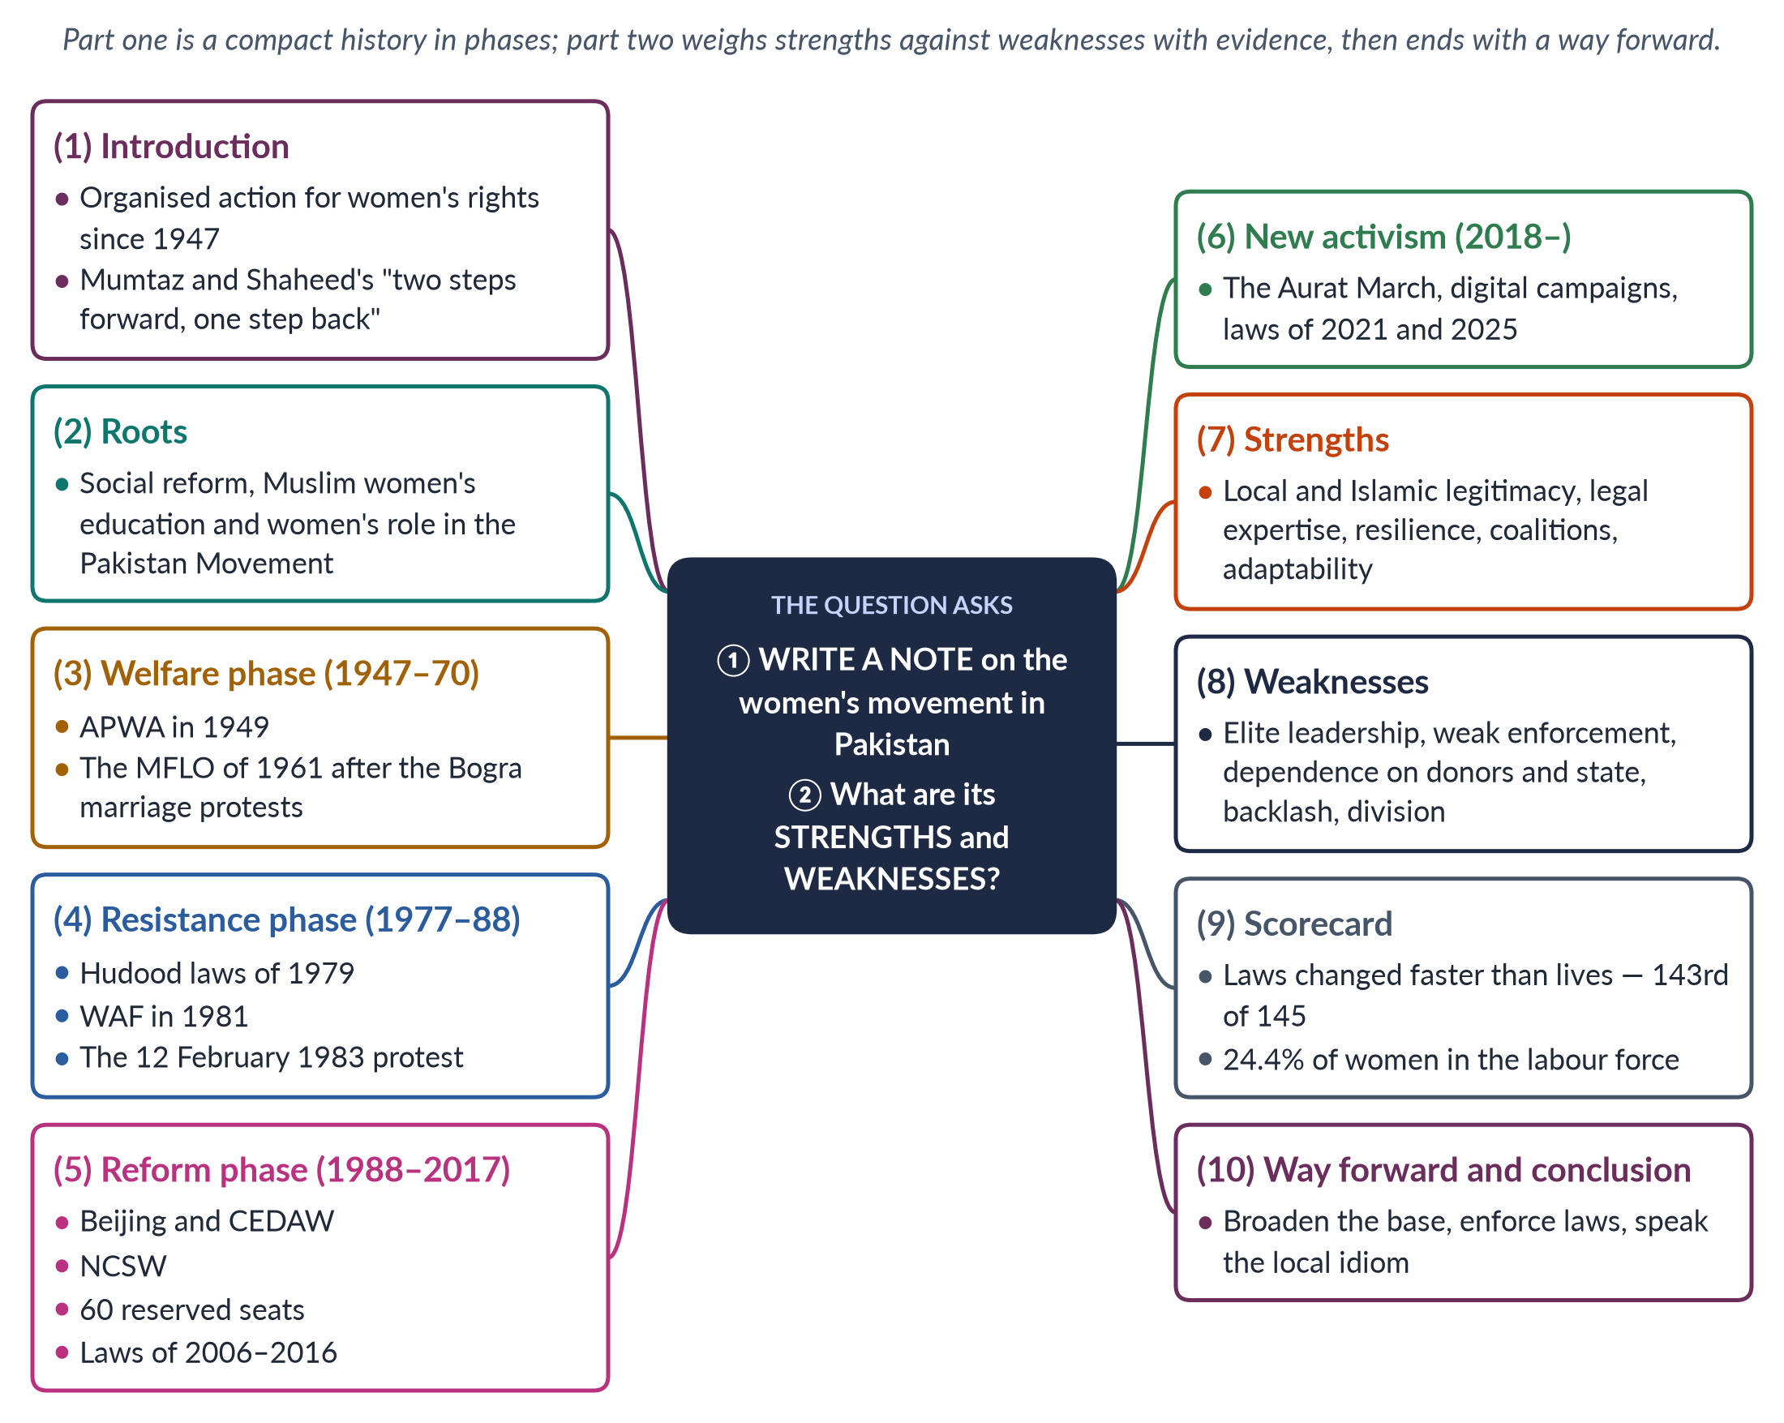
Figure 1 · The answer map: every branch is one numbered heading of the model answer below.

Decoding the question
Two parts. "Write a note" asks for a clear, organised account — best given as phases with dates, organisations and laws. "Strengths and weaknesses" asks for evaluation, and it should carry at least half the marks. Give each strength and weakness its own sub-heading and evidence, and end with a short way forward.

The model answer

1. Introduction

i) Definition
The women's movement in Pakistan is the organised, collective effort — by women's organisations, activists, lawyers, legislators and ordinary women — to improve women's rights and status since independence.

ii) Background
Its standard history, by Khawar Mumtaz and Farida Shaheed, is titled Women of Pakistan: Two Steps Forward, One Step Back? (1987). The title sums up its story: real gains, repeated setbacks.

iii) The argument
The movement's great strength is that it changed the law; its great weakness is that it has changed daily life far more slowly, because its base has been narrow and enforcement weak.

iv) Who took part
The movement is a network: elite welfare workers (APWA), secular activists (WAF), rural women (the Sindhiani Tehreek, from 1982), health workers, religious women's groups, lawyers, legislators and, since 2018, young digital activists.

2. Roots

i) Reform and education
The movement grew from nineteenth-century reform — Sayyid Mumtaz Ali's Huquq-un-Niswan (1898) argued for women's rights from Islam — and from Muslim girls' schools such as Aligarh (1906).

ii) The Pakistan Movement
The Muslim League formed a women's sub-committee in 1938. Fatima Jinnah, Begum Jahanara Shahnawaz and Begum Shaista Ikramullah led women into politics. The Quaid said in 1944: "No nation can rise to the height of glory unless your women are side by side with you."

3. The welfare phase (1947–1970)

i) APWA
The All Pakistan Women's Association was founded in 1949 by Begum Ra'ana Liaquat Ali Khan. It ran schools, colleges, clinics and craft centres — a welfare approach in cooperation with the state.

ii) Family law
When Prime Minister Bogra took a second wife (1955), women protested. The Rashid Commission followed, and then the Muslim Family Laws Ordinance 1961: registration of marriages and restrictions on polygamy and unilateral divorce.

4. The resistance phase (1977–1988)

i) Zia's laws
General Zia-ul-Haq's Hudood Ordinances (1979) meant a woman who reported rape but could not prove it risked a charge of zina herself.

ii) WAF and 12 February 1983
The Women's Action Forum was founded in Karachi in 1981. On 12 February 1983, WAF and women lawyers marched in Lahore against the proposed Law of Evidence and were baton-charged. The day is now National Women's Day (since 2012).

5. The reform phase (1988–2017)

i) Democracy and the UN
Benazir Bhutto became prime minister in 1988. Pakistan joined the Beijing process (1995) and acceded to CEDAW in 1996.

ii) Machinery and laws
The NCSW (2000); 60 reserved National Assembly seats (2002); the Protection of Women Act 2006; laws on harassment (2010), acid (2011) and honour killing (2016).

6. New activism (2018 onwards)

i) The Aurat March
Since 8 March 2018, the Aurat March has brought young women onto the streets with demands on violence, harassment, work and bodily autonomy.

ii) Digital activism
Online campaigns after the killing of Qandeel Baloch (2016) and the Lahore motorway gang rape (2020) pushed the state to act quickly.

iii) New laws
The Anti-Rape (Investigation and Trial) Act 2021 and the Islamabad Child Marriage Restraint Act 2025 (minimum age 18).
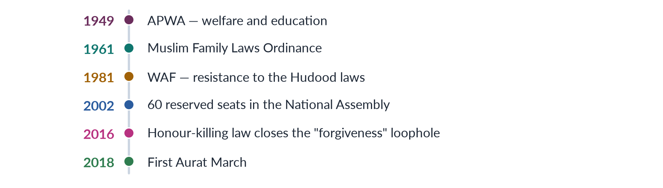
Figure 2 · The women's movement in Pakistan in six milestones.

7. Strengths

i) Local and Islamic legitimacy
From Mumtaz Ali to the MFLO, the movement has argued from Islam and the Constitution (Articles 25 and 34), answering the charge of a "Western agenda". The 1948 Punjab inheritance law and the MFLO 1961 were both defended as restoring Islamic rights denied by custom.

ii) Legal expertise
Women lawyers such as Asma Jahangir and Hina Jilani — founders of the first all-women law firm (1980) and of AGHS Legal Aid — defended women in Hudood cases and turned protest into litigation and legislation.

iii) Resilience
WAF kept resisting under martial law, when political parties were silenced.

iv) Coalitions
The cross-party Women's Parliamentary Caucus (2008), NGOs and activists together passed the laws of 2010–2016.

v) Adaptability
The movement moved from welfare to law to digital activism as conditions changed. Each time it seemed to stall — after APWA, after WAF, after the NGO years — a new generation found new methods.

vi) A research base
Shirkat Gah (1975), the Aurat Foundation (1986) and the HRCP (1987) produced the evidence on violence, work and law that legislators needed.

8. Weaknesses

i) A narrow base
Leadership has been urban, educated and middle-class. Rural and working women were often represented rather than leading.

ii) The enforcement gap
Many laws are weakly implemented by police and courts, and resisted by communities. Honour killings continue years after the 2016 law; harassment committees exist on paper in many offices but not in practice.

iii) Dependence
Gains came through sympathetic governments or donor funds, and could be reversed — as under Zia. NGO-isation turned some activism into projects.

iv) Backlash and the "Western" label
Conservative opposition, and provocative slogans, let critics paint the movement as foreign.

v) Division
Secular versus Islamic feminists, liberal versus left, old versus young. These splits make it harder to present one agenda to the state.
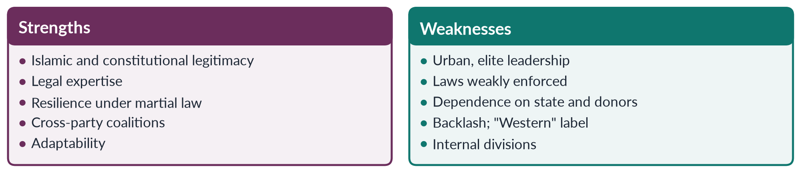
Figure 3 · The movement's strengths and weaknesses.

9. The scorecard
Pakistan ranked 143rd of 145 in the Global Gender Gap Report 2026. Only 24.4% of women are in the labour force (LFS 2024–25), and only 11 women won general National Assembly seats in 2024. The laws have changed faster than lives. The movement's record is therefore strong in law and institutions, and weaker in economic and social change — which is exactly where its weaknesses (narrow base, poor enforcement) bite.

10. Way forward and conclusion

i) Way forward
Broaden the base so that rural, working and minority women lead, not only benefit; move from law to enforcement; build local funding; form alliances with parties, unions, religious scholars and men; and speak the local idiom of the Constitution and Islamic justice.

ii) Conclusion
Pakistan's women's movement has taken real steps forward — the MFLO, the 2006 Act, reserved seats, the honour-killing law — and has survived steps back, from Zia's laws to today's backlash. Its future depends on turning rights on paper into rights in practice for the majority of women.

Why this answer scores
- Both parts answered: a phased history, then a full evaluation.
- Every strength and weakness has its own sub-heading and evidence.
- A timeline and a compare figure show the story and the balance at a glance.
- Current data (GGGR 2026, LFS 2024–25) make the evaluation concrete.

Answer 2 · Short Note: APWA and WAF (CSS 2018)
AT A GLANCE · CSS 2018 · Q8(B) · 10 MARKS
Write short notes on any TWO: APWA and WAF

The answer map
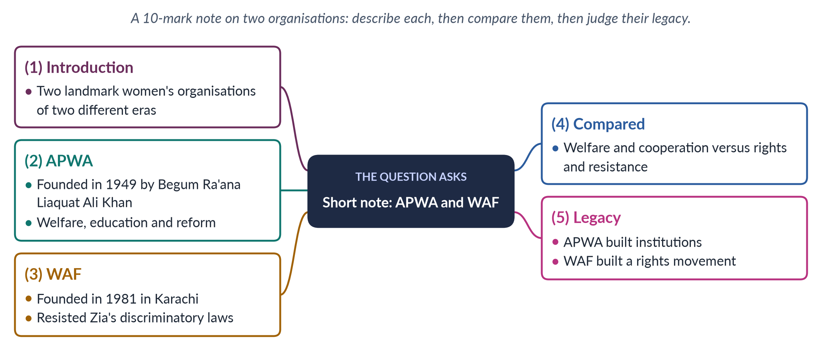
Figure 4 · The answer map for the short note: every branch is one headed point.

Decoding the question
A short note of 10 marks on two organisations: about 550–650 words. Give each its founding, aims, methods and achievements, then compare them — a table or compare figure is ideal — and end with their significance.

The model answer

1. Introduction
Pakistan's women's movement has worked through organisations as much as through individuals. The All Pakistan Women's Association (APWA) and the Women's Action Forum (WAF) are the two most important women's organisations in Pakistan's history. They represent two phases of the movement: welfare and reform after independence, and rights and resistance under military rule.

2. APWA (1949)

i) Founding
APWA was founded in 1949 by Begum Ra'ana Liaquat Ali Khan, wife of the first prime minister, who was also its first president. It grew out of women's relief work for refugees during Partition.

ii) Aims and work
A non-political welfare organisation, it set up schools, colleges, vocational centres, clinics and cottage industries for women across the country. Its branches spread to every province, and it gained consultative status with the United Nations.

iii) Advocacy
APWA also pressed for reform. After Prime Minister Bogra took a second wife (1955), APWA led protests that contributed to the Rashid Commission and the Muslim Family Laws Ordinance 1961, which regulated polygamy and divorce and required registration of marriages.

3. WAF (1981)

i) Founding
WAF was founded in Karachi in 1981, soon spreading to Lahore, Islamabad and Peshawar. It was formed after a court sentenced Fehmida and Allah Bux to stoning for zina under the Hudood Ordinances (1979).

ii) Character
A non-hierarchical, non-party, secular platform of women's groups and individuals, refusing donor funding to keep its independence. Decisions were taken collectively, with no president or permanent leader.

iii) Struggle
WAF challenged the Hudood Ordinances, the proposed Law of Evidence, and restrictions on women in media and sport. On 12 February 1983, WAF members and women lawyers were baton-charged by police in Lahore — the day is now National Women's Day. WAF also documented Hudood cases such as that of Safia Bibi (1983), a young rape victim convicted of zina, whose case caused a national outcry.

4. APWA and WAF compared
Table 2 · APWA and WAF compared.
Point | APWA | WAF
Founded | 1949, by Begum Ra'ana Liaquat Ali Khan | 1981, Karachi, after the Fehmida–Allah Bux case
Era | Nation-building after independence | Zia-ul-Haq's martial law
Aim | Welfare, education, skills, health | Resist discriminatory laws; women's rights
Method | Service; cooperation with the state | Protest, lobbying, legal analysis, media
Politics | Non-political, reformist | Secular, non-party, confrontational
Achievement | Institutions for women; support for the MFLO 1961 | Resistance to Hudood laws; a rights movement
Criticism | Elite charity; avoided hard politics | Urban and middle-class; limited rural reach

5. Legacy

i) What each gave
APWA showed that women could build national institutions, and made girls' education respectable. WAF turned women's issues into political rights, gave women a collective voice against a military ruler, and trained a generation of activists, lawyers and legislators whose work led to later laws — from the Protection of Women Act 2006 to the honour-killing law of 2016.

ii) Shared limits
Both were led by educated, urban women; both struggled to reach rural and working women, who organised separately in movements such as the Sindhiani Tehreek.

iii) Conclusion
Their differences reflect their times: APWA worked with a friendly new state; WAF faced a hostile military regime. APWA and WAF are best seen as two stages of one movement: first service, then resistance. Today's Aurat March inherits WAF's spirit of protest and APWA's commitment to women's welfare.

Why this answer scores
- Each organisation gets founding, aims, methods and achievements with exact dates.
- A comparison table answers the implicit "compare" in a two-part note.
- The legacy section links both to later laws and the Aurat March.

Answer 3 · The Three Waves of Western Feminism and Their Influence on Pakistan (CSS 2019; repeated 2023)
AT A GLANCE · CSS 2019 · Q3 · 20 MARKS
Outline and explain the three major waves of feminist movements in the West. Discuss the influence of these waves on feminist movements in Pakistan.

The answer map
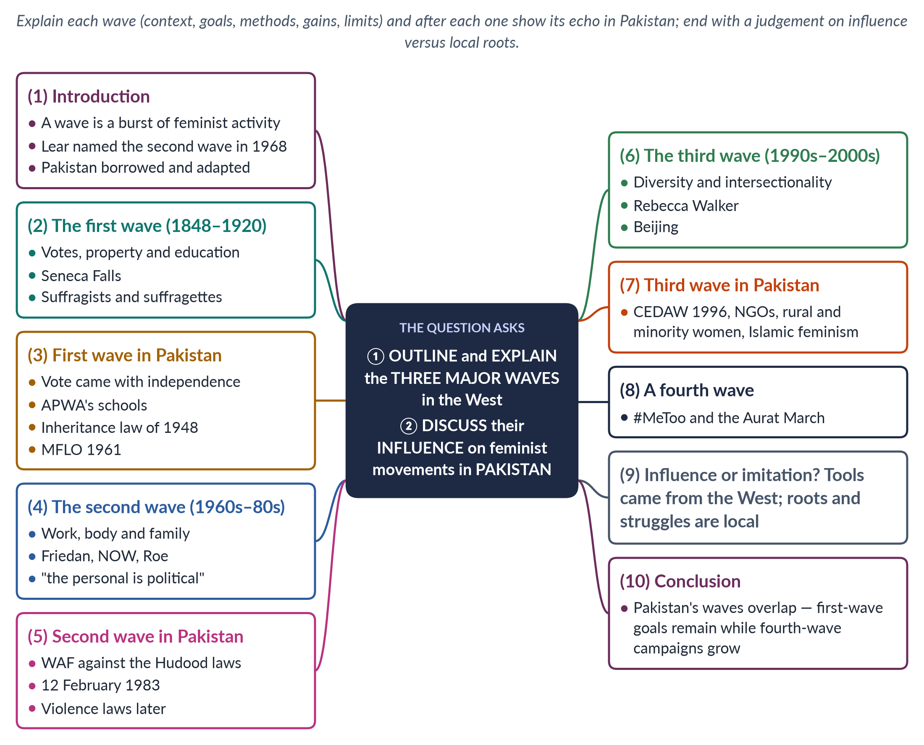
Figure 5 · The answer map: every branch is one numbered heading of the model answer below.

Decoding the question
Two command words. "Outline and explain" asks for each wave's context, goals, methods, leaders, achievements and limits — not a list of dates. "Discuss the influence … on Pakistan" asks for evidence of links and a judgement: was Pakistan's movement shaped by the West, or did it grow from its own roots? The best structure puts a "In Pakistan" heading after each wave, then a final heading weighing influence against local roots. (The 2023 paper repeated this question word for word.)

The model answer

1. Introduction

i) Definition
A wave of feminism is a period of intense, organised activity for women's rights, with shared goals and methods. The journalist Martha Weinman Lear coined "the second feminist wave" in 1968, and the earlier suffrage campaign became the "first wave".

ii) The three waves
The first wave (c. 1848–1920) fought for legal personhood and the vote; the second (1960s–1980s) for equality in work, family and the body; the third (1990s–2000s) for diversity and inclusion.

iii) The argument
Each wave reached Pakistan — through education, the United Nations, donors and the media — but Pakistani women adapted what they borrowed to Islam, local culture and their own political struggles, and the waves arrived mixed together rather than one after another.

2. The first wave (c. 1848–1920)

i) Context
In the nineteenth century women in Britain and the United States could not vote; under coverture, a married woman's property and legal identity belonged to her husband; universities and professions were closed.

ii) Seneca Falls
Refused seats at the World Anti-Slavery Convention in London (1840), Elizabeth Cady Stanton and Lucretia Mott organised the Seneca Falls Convention (1848). Its Declaration of Sentiments proclaimed that "all men and women are created equal".

iii) Methods
In Britain, suffragists (NUWSS, 1897, Millicent Fawcett) used petitions and lobbying; suffragettes (WSPU, 1903, Emmeline Pankhurst) used militant action under the slogan "Deeds, not words".

iv) Achievements and limits
New Zealand gave women the vote in 1893, Britain in 1918 and 1928, the USA in 1920; married women won property rights; universities opened. But the wave was mostly white and middle-class, and it left the family untouched.

3. The first wave in Pakistan

i) The vote with independence
Pakistani women did not need a suffrage movement: universal adult franchise came with independence in 1947, won partly by women's role in the Pakistan Movement.

ii) Education and property
First-wave goals shaped the early movement. APWA (1949, Begum Ra'ana Liaquat Ali Khan) built girls' schools and colleges. Women legislators won the West Punjab Muslim Personal Law (Shariat) Application Act 1948, giving women inheritance in agricultural land.

iii) Legal status in Islamic terms
The Muslim Family Laws Ordinance 1961 regulated polygamy and divorce — a first-wave kind of legal reform, argued as restoring Islamic rights against custom.

4. The second wave (1960s–1980s)

i) Context
Women could vote, but they were paid less, kept out of many jobs, denied contraception and abortion, and unprotected against violence at home.

ii) Leaders and ideas
Betty Friedan's The Feminine Mystique (1963) described "the problem that has no name"; she co-founded NOW (1966). Radical feminists such as Kate Millett (1970) and Carol Hanisch gave the slogan "the personal is political".

iii) Achievements
The US Equal Pay Act (1963) and Title VII (1964); Roe v. Wade (1973) on abortion; women's shelters (London, 1971) and rape crisis centres; sexual harassment recognised as discrimination.

iv) Limits
bell hooks (1981) criticised the wave for speaking for white, middle-class women and ignoring race and class.

5. The second wave in Pakistan

i) WAF and the Hudood laws
The second wave arrived as the Women's Action Forum (1981). Zia-ul-Haq's Hudood Ordinances (1979) exposed rape victims to charges of zina. WAF's resistance was a second-wave struggle over the body, sexuality and violence.

ii) 12 February 1983
WAF and women lawyers marching against the Law of Evidence were baton-charged in Lahore; the day is now National Women's Day.

iii) Adaptation
Unlike the American second wave, WAF avoided open debate on sexuality and argued largely in constitutional and Islamic terms. It invited religious scholars to debate interpretation of the Hudood laws. Its legacy includes the Protection of Women Act 2006, which moved rape out of the Zina Ordinance, and later laws on harassment (2010) and honour killing (2016).

6. The third wave (1990s–2000s)

i) Context
After the Anita Hill hearings (1991), Rebecca Walker wrote "Becoming the Third Wave" (1992): "I am not a post-feminism feminist. I am the Third Wave."

ii) Ideas
The third wave stressed diversity: intersectionality (Crenshaw, 1989), Black feminism (hooks), postmodern and queer thought (Butler, 1990) and postcolonial critique (Mohanty, 1984).

iii) Methods and gains
Culture — music, zines, media — and global networks. The Beijing conference (1995) declared "women's rights are human rights".

iv) Limits
Critics said it was individualistic and easily turned into marketing ("girl power").

7. The third wave in Pakistan

i) The UN and CEDAW
Pakistan took part in Beijing (1995) — Benazir Bhutto spoke — and acceded to CEDAW in 1996.

ii) NGOs and diversity
An NGO boom followed, with attention to rural, minority and poor women, later to khawaja siras (Supreme Court 2009).

iii) Islamic feminism
Pakistani-born scholars Riffat Hassan and Asma Barlas re-read Islamic sources — matching the third wave's rejection of one Western model of the liberated woman.
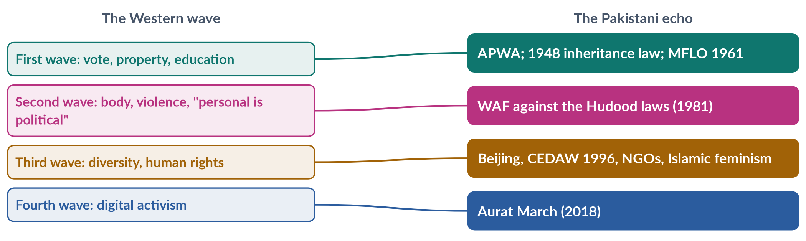
Figure 6 · Each Western wave and its echo in Pakistan.

8. A fourth wave
Since about 2012, social media has driven a fourth wave — #MeToo (2017). In Pakistan its echo is the Aurat March (from 2018), whose demands on violence, harassment and bodily autonomy are fourth-wave in style and local in content.

9. Influence or imitation?

i) The case for strong influence
Terms, methods and money came from the West and the UN: consciousness-raising, legal advocacy, gender mainstreaming, hashtags. Many leaders were Western-educated, and the UN process after 1975 created Pakistan's women's machinery — the Women's Division (1979) and the NCSW (2000).

ii) The case for local roots
Pakistan's movement began earlier, with Mumtaz Ali's Huquq-un-Niswan (1898) and women in the Pakistan Movement. It faced a state that used religion to restrict women, and it answered in Islamic and constitutional terms.

iii) Judgement
The West supplied tools and platforms; Pakistani women chose, adapted and sometimes rejected them in their own struggles.

10. Conclusion
The three Western waves moved from legal rights to equality in private life to diversity. Each reached Pakistan — as APWA's schools, WAF's resistance and the NGO and CEDAW era — but in Pakistan the waves overlap: first-wave goals such as girls' schooling and women's inheritance are still unfinished while fourth-wave campaigns run online. Pakistan's movement is best described as global in its tools and local in its struggles.

Why this answer scores
- Each wave is explained — context, leaders, methods, gains, limits — not just listed.
- An "In Pakistan" heading after each wave answers the second part throughout, not in one paragraph at the end.
- A mapping figure links each wave to its Pakistani echo.
- The answer ends with a reasoned judgement on influence versus local roots, and notes the fourth wave for extra credit.

Answer 4 · The First Wave and the Third Wave of Feminism (CSS 2022)
AT A GLANCE · CSS 2022 · Q4 · 20 MARKS
Shed light on the first wave and third wave of feminism.

The answer map
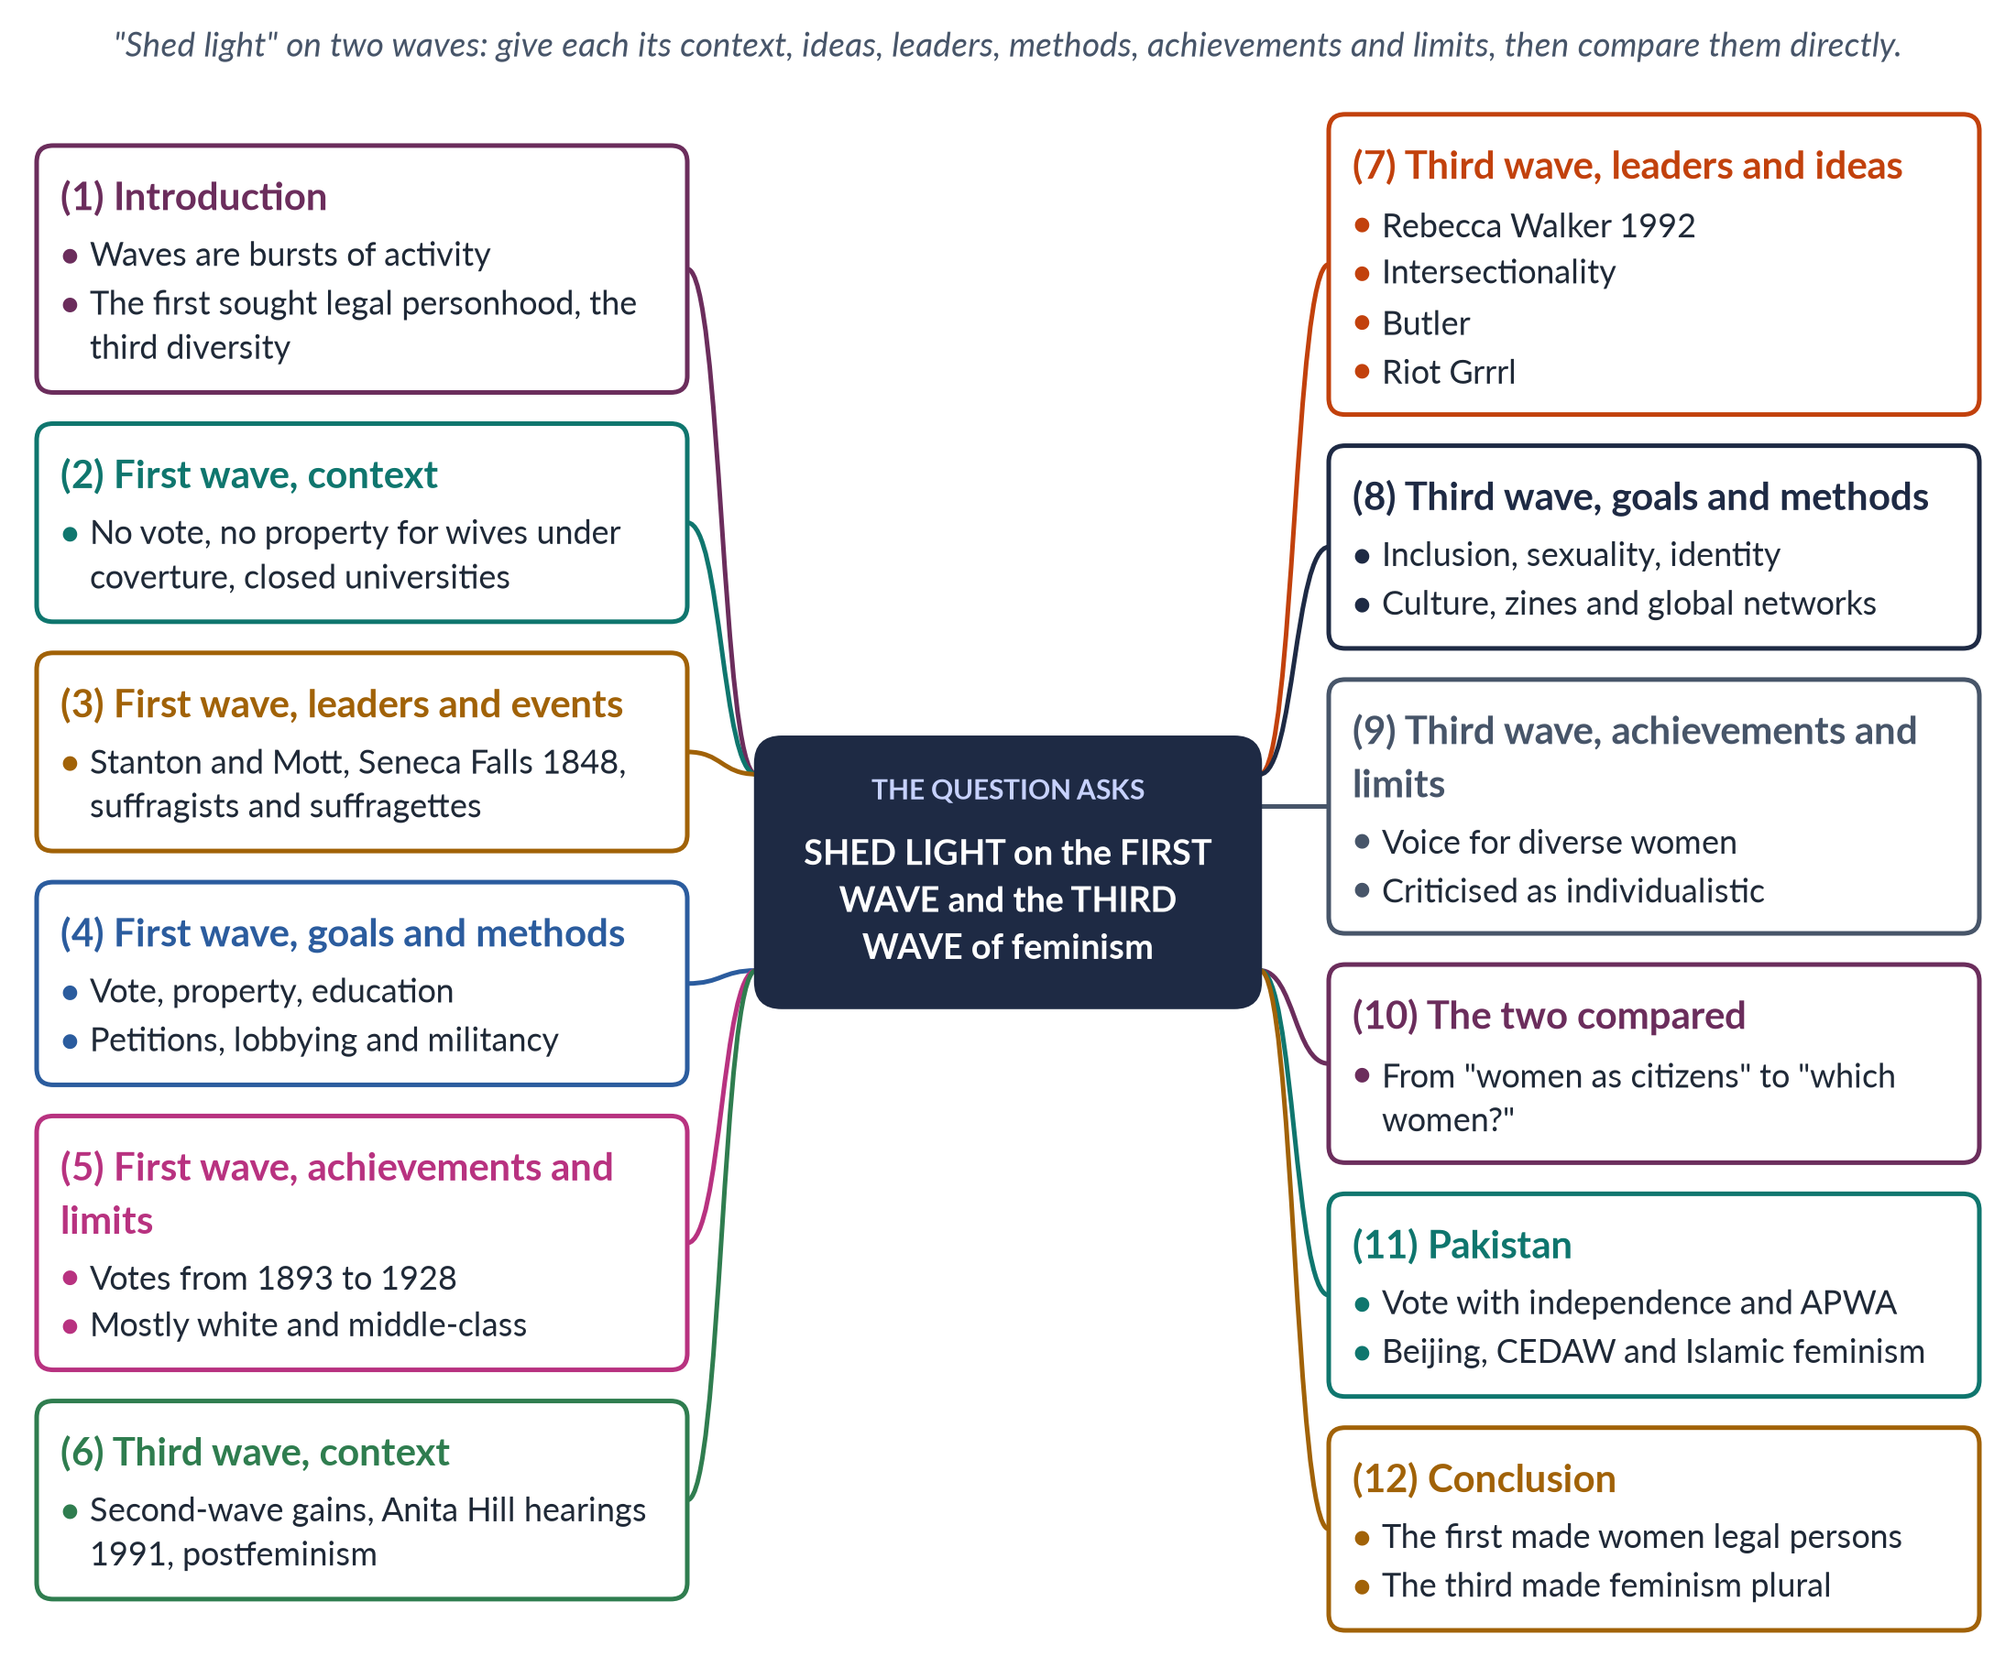
Figure 7 · The answer map: every branch is one numbered heading of the model answer below.

Decoding the question
"Shed light on" means explain clearly, with enough detail to show understanding. Two waves are named, so give each a balanced share: context, ideas, leaders, goals, methods, achievements and limits. Because they are a century apart, a direct comparison adds depth, and a short Pakistan link shows application.

The model answer

1. Introduction

i) Definition
A wave of feminism is a period of intense, organised activity for women's rights with shared goals and methods. The metaphor was made popular by Martha Weinman Lear in 1968.

ii) The two waves
The first wave (c. 1848–1920) sought women's legal personhood and the vote. Between them lay the second wave (1960s–1980s), which fought over work, family and the body. The third wave (1990s–2000s) sought diversity and inclusion — asking not only "are women equal?" but "which women?"

iii) The argument
The first wave made women citizens; the third made feminism plural. Together they show how the meaning of equality widened over a century.

2. The first wave — context

i) Women without legal existence
In nineteenth-century Britain and America, women could not vote or hold office. Under coverture, a married woman's legal identity was absorbed into her husband's: she could not own property, sign contracts or keep her wages.

ii) Closed doors
Universities and professions were closed to women, and in separation fathers usually received custody of children.

iii) Sources of the movement
Enlightenment ideas of natural rights, Mary Wollstonecraft's Vindication (1792), and women's experience in the anti-slavery movement.

3. The first wave — leaders and events

i) Seneca Falls
Elizabeth Cady Stanton and Lucretia Mott, refused seats at the World Anti-Slavery Convention in London (1840), organised the Seneca Falls Convention (1848). Its Declaration of Sentiments stated that "all men and women are created equal" and demanded the vote.

ii) The American campaign
Susan B. Anthony and Stanton founded the National Woman Suffrage Association (1869). The 19th Amendment (1920) gave American women the vote.

iii) Britain
Suffragists of the NUWSS (1897), led by Millicent Fawcett, used peaceful methods. Suffragettes of the WSPU (1903), led by Emmeline Pankhurst, used militant tactics — window-smashing, arson and hunger strikes — under the slogan "Deeds, not words".

4. The first wave — goals and methods

i) Goals
The vote; property rights for married women; education and entry to the professions; custody of children; reform of divorce law.

ii) Methods
Conventions, petitions, lobbying, newspapers and marches, and — in Britain — militant direct action.

iii) Theory
The first wave was liberal: women are rational individuals with equal rights (J. S. Mill, The Subjection of Women, 1869).

5. The first wave — achievements and limits

i) Achievements
Votes for women in New Zealand (1893), Finland (1906), Britain (1918, equal in 1928) and the USA (1920); the Married Women's Property Acts (1870, 1882); women's colleges and the first women doctors.

ii) Limits
The movement was mostly white and middle-class; some suffragists used racist arguments, and Black women in the American South could not vote freely until 1965. Once the vote was won, the family, work and sexuality were left almost untouched.

6. The third wave — context

i) Inheritors of the second wave
Young women of the 1990s grew up with second-wave gains — equal-pay laws, contraception, women at university — yet still faced harassment and violence.

ii) The spark
The Anita Hill hearings (1991), where an all-male Senate committee harshly questioned a woman who accused a Supreme Court nominee of harassment, angered many young women.

iii) Against postfeminism
The media claimed feminism was over — "postfeminism", the idea that equality had been won and any remaining gap was a matter of personal choice. The third wave rejected this claim, pointing to harassment, violence and the pay gap.

7. The third wave — leaders and ideas

i) Rebecca Walker
In "Becoming the Third Wave" (Ms., 1992), Rebecca Walker wrote: "I am not a post-feminism feminist. I am the Third Wave."

ii) Theory
Intersectionality (Kimberlé Crenshaw, 1989) and Black feminism (bell hooks) showed that gender overlaps with race, class and sexuality. Judith Butler (Gender Trouble, 1990) argued that gender is performative. Chandra Mohanty (1984) criticised Western feminists for speaking for "Third World women".

iii) Culture
Riot Grrrl punk bands and handmade zines (from 1991); Naomi Wolf's The Beauty Myth (1990); Eve Ensler's The Vagina Monologues (1996).

8. The third wave — goals and methods

i) Goals
Inclusion of women of colour, lesbian and transgender women, and women of the global South; sexual freedom and positive self-image; action on violence and harassment; global human rights.

ii) Methods
Music, zines, art and media; campus activism and voter registration; the early internet; transnational networks linked by Vienna (1993) and Beijing (1995).

9. The third wave — achievements and limits

i) Achievements
Feminism became plural and inclusive; intersectionality entered law and policy; violence against women became a human-rights issue (the US Violence Against Women Act, 1994).

ii) Limits
Critics called it individualistic — "choice feminism" — and too easily turned into marketing ("girl power"). Without a single goal it was less visible than earlier waves.

10. The two waves compared
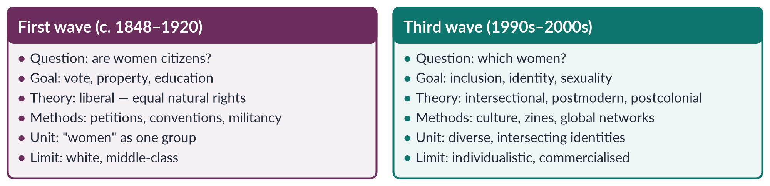
Figure 8 · The first and third waves side by side.
The first wave treated women as one group seeking entry to public life; the third wave insisted that women are many groups with different needs. The third wave corrected the first's blind spot on race and class. Yet the two share a core: both believed that women's position is made by society, not nature, and can be changed by organised action. The first changed laws; the third changed who feminism speaks for.

11. The Pakistan angle

i) First-wave goals
Pakistani women received the vote with independence (1947). First-wave goals — education and property — shaped APWA (1949) and the 1948 Punjab inheritance law.

ii) Third-wave themes
Beijing (1995) and CEDAW (1996), the NGO boom, attention to rural and minority women, and Islamic feminism (Riffat Hassan, Asma Barlas) carry third-wave ideas of diversity.

12. Conclusion
The first wave gave women legal existence — the vote, property and education. The third wave, a century later, made feminism plural — recognising that race, class, sexuality and nation shape what equality means. The first opened the door to citizenship; the third made sure that door was open to every woman — Black and white, rich and poor, Western and Southern, and, in Pakistan, rural as well as urban.

Why this answer scores
- Both waves get equal, structured treatment under the same sub-headings.
- Exact names, dates and books (Seneca Falls 1848, Walker 1992, Crenshaw 1989).
- A compare figure turns two descriptions into analysis.
- A short Pakistan angle shows application without drifting from the question.

Answer 5 · Feminist Movements in Pakistan (CSS 2022)
AT A GLANCE · CSS 2022 · Q6 · 20 MARKS
Discuss in detail feminist movements in Pakistan.

The answer map
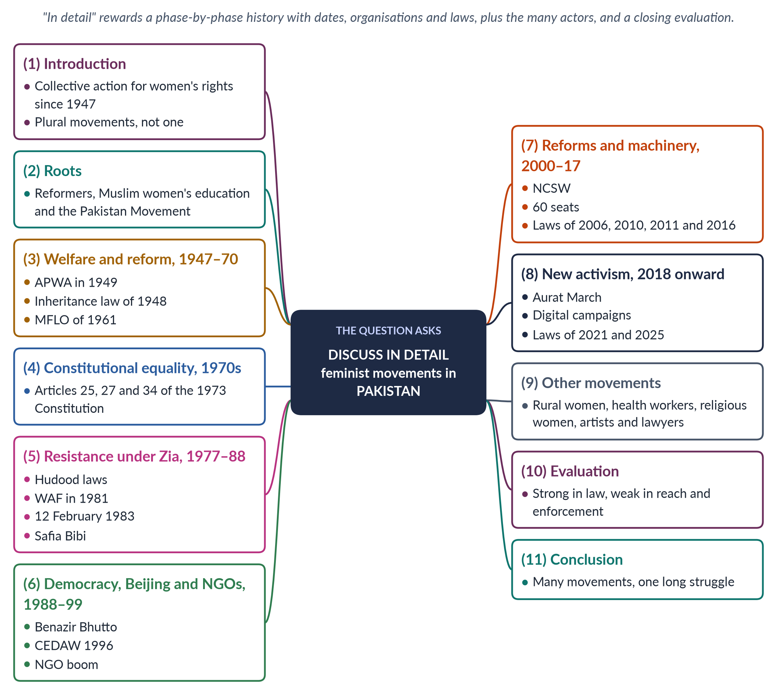
Figure 9 · The answer map: every branch is one numbered heading of the model answer below.

Decoding the question
"Discuss in detail" asks for a full, organised account — the plural "movements" invites you to show that there has been more than one movement: elite welfare, secular rights, rural, religious and digital. The strongest structure is phase by phase (with dates, organisations, laws and leaders), then a heading on other actors, then a brief evaluation.

The model answer

1. Introduction

i) Definition
Feminist movements in Pakistan are the organised, collective efforts of women — and supportive men — to secure women's rights and change their status since 1947.

ii) Scholarship
Khawar Mumtaz and Farida Shaheed's Women of Pakistan: Two Steps Forward, One Step Back? (1987) remains the standard history.

iii) The argument
Pakistan has had several movements, not one: welfare-oriented, rights-based, rural, religious and digital. Together they have changed the law substantially, while daily life has changed more slowly.

2. Roots before 1947

i) Reform
Sayyid Mumtaz Ali's Huquq-un-Niswan (1898) argued for women's rights from the Qur'an; girls' schools such as Aligarh (1906) spread education.

ii) The Pakistan Movement
The Muslim League's women's sub-committee (1938) drew women into politics under Fatima Jinnah, Begum Jahanara Shahnawaz and Begum Ra'ana Liaquat Ali Khan.

3. Welfare and reform (1947–1970)

i) Partition relief and APWA
Women's relief work during Partition led to the All Pakistan Women's Association (1949), founded by Begum Ra'ana Liaquat Ali Khan — schools, colleges, clinics and crafts.

ii) Inheritance (1948)
Women legislators and demonstrators won the West Punjab Muslim Personal Law (Shariat) Application Act 1948, giving women inheritance in agricultural land.

iii) Family law (1961)
After protests over PM Bogra's second marriage (1955) came the Rashid Commission and the Muslim Family Laws Ordinance 1961 — registration of marriage, and restrictions on polygamy and unilateral divorce.

4. Constitutional equality (1970s)
The 1973 Constitution guaranteed equality before law and non-discrimination on the basis of sex (Article 25), non-discrimination in public service (Article 27) and women's full participation in national life (Article 34). Begum Ra'ana Liaquat Ali Khan became Governor of Sindh (1973), and women entered the foreign service and other cadres. For International Women's Year (1975) the government set up a committee on women's rights. This was a period of promises from above rather than mass mobilisation — the Constitution gave activists a legal standard they would use for decades.

5. Resistance under Zia (1977–1988)

i) The laws
The Hudood Ordinances (1979) made it possible for rape victims unable to prove rape to be charged with zina. The Qanun-e-Shahadat (1984) required two women witnesses in some financial matters.

ii) WAF
The Women's Action Forum, founded in Karachi in 1981 after the Fehmida–Allah Bux stoning sentence, was secular, non-party and non-hierarchical.

iii) 12 February 1983
WAF and women lawyers marching in Lahore were baton-charged; the day is now National Women's Day. The Safia Bibi case (1983) — a visually impaired rape victim convicted of zina — caused national outrage.

6. Democracy, Beijing and NGOs (1988–1999)

i) A woman prime minister
Benazir Bhutto (1988) set up the First Women Bank (1989), women's police stations and the Lady Health Worker Programme (1994).

ii) The UN
Pakistan joined Beijing (1995) and acceded to CEDAW (1996).

iii) NGOs
Shirkat Gah (1975), Aurat Foundation (1986) and many others researched, provided legal aid and lobbied. The HRCP (1987) documented violence against women, and the killing of Samia Sarwar in her lawyer's office (1999) brought honour killing to national attention.

iv) The limits of the decade
Despite a woman prime minister, the Hudood laws were not repealed — a sign of how strong conservative opposition remained.

7. Reforms and machinery (2000–2017)

i) Institutions
The NCSW (2000); 33% local-government seats (2001); 60 reserved National Assembly seats (2002); the Women's Parliamentary Caucus (2008).

ii) Laws
The Protection of Women Act 2006 moved rape to the Penal Code; laws on workplace harassment (2010), acid attacks and anti-women practices (2011), and honour killing (2016) followed. The murder of Qandeel Baloch by her brother (2016) spurred Parliament to close the "forgiveness" loophole in honour killings.

iii) State feminism
This phase shows state feminism — women's rights advanced through Parliament, commissions and ministries, with women legislators of all parties working with NGOs.
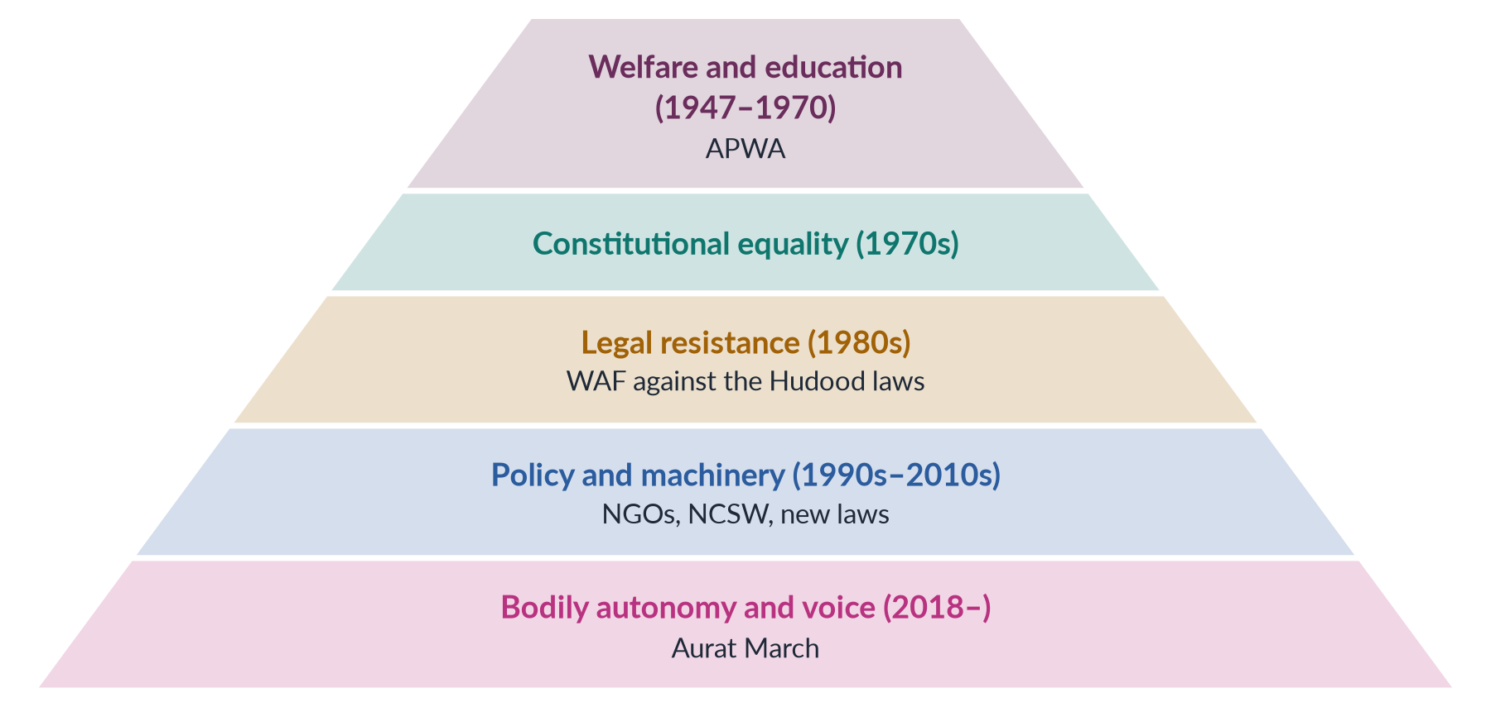
Figure 10 · The changing focus of Pakistan's feminist movements.

8. New activism (2018 onward)

i) The Aurat March
Since 8 March 2018, young, urban women have marched against violence, harassment and unequal work, and for khawaja sira rights and bodily autonomy.

ii) Digital campaigns
Online outrage after the Lahore motorway gang rape (2020) helped produce the Anti-Rape (Investigation and Trial) Act 2021.

iii) New laws
The Islamabad Child Marriage Restraint Act 2025 set the minimum age at 18.

9. Other movements and actors

i) Rural and working women
The Sindhiani Tehreek (from 1982) mobilised rural Sindhi women; Lady Health Workers won regularisation through a Supreme Court order (2012); home-based workers won the Sindh Home-Based Workers Act 2018.

ii) Religious women
The women's wing of the Jamaat-e-Islami and Al-Huda (1994) organised women within a religious framework, sometimes opposing secular feminists.

iii) Left and workers' feminism
The Women Democratic Front (2018) links women's rights with workers' rights, and trade unions of home-based and domestic workers have joined the Aurat March.

iv) Artists and lawyers
Poets Kishwar Naheed and Fahmida Riaz, the theatre group Tehrik-e-Niswan (1979), and lawyers Asma Jahangir and Hina Jilani gave the movement voice and legal skill.

10. Evaluation

i) Strengths
Constitutional and Islamic legitimacy; legal expertise; resilience under martial law; coalitions that produced laws.

ii) Weaknesses
Urban, elite leadership; weak enforcement; dependence on donors and the state; backlash and the "Western agenda" label. The different movements — secular and religious, elite and rural — have also found it hard to act together, except on specific laws.

iii) The scorecard
The laws have changed faster than lives. Pakistan ranked 143rd of 145 in the Global Gender Gap Report 2026; women's labour-force participation is 24.4% (LFS 2024–25).

11. Conclusion
Pakistan's feminist movements have moved from welfare to constitutional equality, from legal resistance to policy reform, and now to bodily autonomy and digital voice. They are many movements — elite and rural, secular and religious, old and young — engaged in one long struggle. Each phase built on the last: APWA's schools produced the educated women who founded WAF; WAF's lawyers drafted the laws of the 2000s; and today's marchers inherit both. Their next task is to turn laws into lived rights for the majority of women.

Why this answer scores
- A phase-by-phase history with exact dates, organisations and laws — true detail.
- The plural "movements" is answered with a heading on rural, religious, artistic and legal actors.
- A pyramid figure shows the changing focus at a glance.
- A short evaluation with current data prevents a purely descriptive answer.

Answer 6 · The Three Waves and Pakistan — the 2023 Repeat (CSS 2023)
AT A GLANCE · CSS 2023 · Q5 · 20 MARKS
Outline and explain the three major waves of feminist movements in the West. Discuss the influence of these waves on feminist movements in Pakistan.

NOTE
This question is word for word the same as CSS 2019 Q3. The full model answer is Answer 3 above. Do not learn a second answer — learn how to refresh the first one.

What to change when a question repeats
The examiner who repeats a question is testing whether candidates can bring it up to date. Keep the structure of Answer 3, and change four things.
1. Update the Pakistan evidence. Add the laws passed since the earlier paper: the Anti-Rape (Investigation and Trial) Act 2021, the Islamabad Child Marriage Restraint Act 2025 (minimum age 18) and the Islamabad Domestic Violence Act 2025.
2. Add the fourth wave. A 2023 answer should mention #MeToo (2017) and the Aurat March (from 2018) as the newest wave and its Pakistani echo — then say briefly that the question asks for three.
3. Use the newest data. Quote the latest Global Gender Gap ranking (143rd of 145 in 2026) and female labour-force participation (24.4%, LFS 2024–25).
4. Sharpen the judgement. Say plainly that Pakistan's waves overlap: first-wave goals (schooling, inheritance) remain unfinished while fourth-wave campaigns grow online.
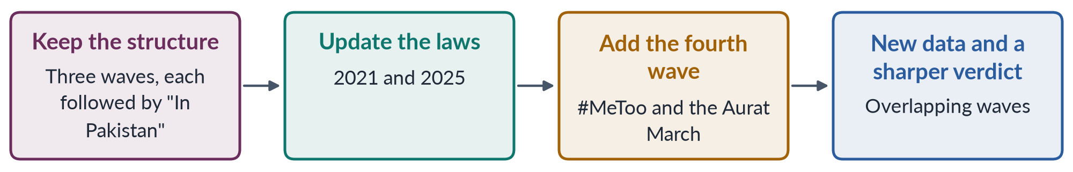
Figure 11 · Refreshing a repeated answer in four steps.
EXAMINER'S EYE · WHY REPEATS MATTER
2016 Q2 and 2023 Q2 (Topic 1) were near repeats; 2019 Q3 and 2023 Q5 were exact repeats. The examiner rewards the candidate whose answer shows this year's Pakistan — not a memorised answer from an old guide.

Answer 7 · Western Feminism's Impact on Pakistan; Past Movements and Emerging Trends (CSS 2024)
AT A GLANCE · CSS 2024 · Q4 · 20 MARKS
Write in detail the impact of Western feminist movements on the feminist movement in Pakistan. Compare Pakistani feminist movements of the past with emerging trends of feminist activism and their effects.

The answer map
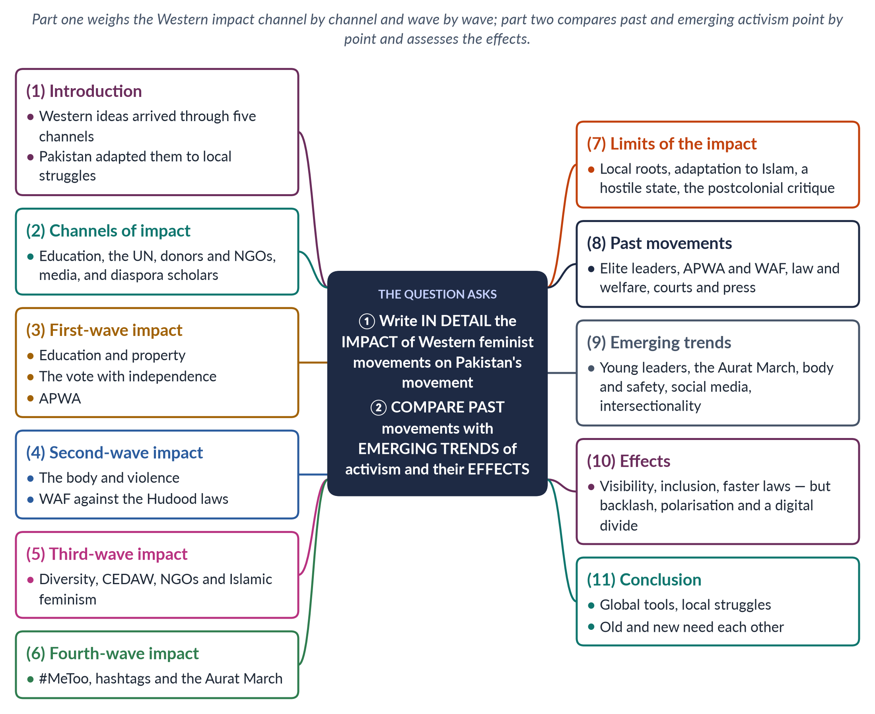
Figure 12 · The answer map: every branch is one numbered heading of the model answer below.

Decoding the question
Two parts, and both carry marks. "Write in detail the impact" asks how, and how far, Western movements shaped Pakistan's — so give channels, wave-by-wave evidence and the limits of influence. "Compare … past … with emerging trends … and their effects" asks for a point-by-point comparison (leaders, organisations, issues, methods, language, relationship with the state) and an assessment of effects.

The model answer

1. Introduction

i) Definition
Western feminist movements are the waves of organised activism in Europe and North America, from the suffrage campaigns of the nineteenth century to digital activism today. Pakistan's feminist movement is the organised struggle for women's rights since 1947.

ii) The argument
Western movements had a strong but selective impact: they supplied ideas, methods, platforms and funds, which Pakistani women adapted to Islam, local culture and their own political battles. The emerging trends of the 2020s — young, digital and focused on the body — differ sharply from the elite, legal activism of the past, with powerful effects both positive and negative.

2. Channels of Western impact

i) Education
Many leaders, from APWA to WAF, studied in Britain or the United States; the Women's Studies centres (1989) taught Western theory.

ii) The United Nations
The world conferences — Mexico City (1975) to Beijing (1995) — and CEDAW (acceded 1996) gave Pakistani activists standards and platforms.

iii) Donors and NGOs
After Beijing, foreign funding supported NGOs working on rights, violence and political participation.

iv) Media and diaspora
Books, satellite television and social media carried ideas; diaspora scholars such as Riffat Hassan and Asma Barlas linked debates across countries.

3. First-wave impact

i) Education and property
First-wave goals — education, property, legal status — shaped APWA (1949) and its schools, and the 1948 Punjab inheritance law.

ii) Adaptation
Pakistani women received the vote with independence (1947), so no suffrage movement was needed; family-law reform (MFLO 1961) was argued in Islamic terms, as restoring rights that custom had denied. The first wave's liberal idea of women as rational citizens entered the 1973 Constitution through Articles 25 and 34.

4. Second-wave impact

i) The body and violence
The second wave's insight that "the personal is political" reached Pakistan as the Women's Action Forum (1981), which resisted the Hudood Ordinances (1979) that punished rape victims.

ii) Adaptation
WAF avoided open debate on sexuality and argued through the Constitution and interpretations of Islam; its legacy was legal — the 2006 Protection of Women Act and the violence laws of 2010–2016. Second-wave methods also travelled: consciousness-raising circles, women's resource centres, legal aid, and the documentation of cases such as Safia Bibi (1983).

5. Third-wave impact

i) Diversity and human rights
Beijing's "women's rights are human rights", CEDAW, and the NGO boom brought attention to rural, minority and poor women and later to khawaja siras.

ii) Islamic feminism
The third wave's rejection of one model of the liberated woman fitted Pakistani scholars re-reading Islamic sources.

iii) Gender mainstreaming
Beijing's call for gender mainstreaming produced Pakistan's National Plan of Action (1998), the NCSW (2000) and the reserved seats of 2002 — Western and UN ideas turned into Pakistani institutions.

6. Fourth-wave impact
#MeToo (2017) and hashtag activism reached Pakistan in 2018. The Aurat March adopted fourth-wave tools — social media, placards designed to be shared, personal testimony — and the language of consent and bodily autonomy. Digital-rights groups such as the Digital Rights Foundation opened helplines against online harassment, and the Prevention of Electronic Crimes Act 2016 gave some legal remedy.

7. Limits of the Western impact

i) Local roots
Pakistan's movement began with local reformers — Mumtaz Ali (1898) — and women's role in the Pakistan Movement.

ii) A different order
The waves arrived together, not in sequence: first-wave goals such as schooling remain unfinished while fourth-wave campaigns grow.

iii) A different enemy
Pakistani women faced a state that used religion to restrict them (Zia), and answered in religious as well as secular terms.

iv) Southern critique
The postcolonial critique (Mohanty, 1984) warned against copying Western feminism, and many Pakistani activists deliberately framed their demands in local languages and local issues — inheritance, dowry, honour killing, forced marriage — that have no exact Western equivalent.

8. Past movements
The movements of 1947 to the 2010s were led by educated, urban, professional women — APWA's welfare workers, WAF's lawyers and activists, NGO researchers. Their issues were welfare, family law and discriminatory laws; their methods were lobbying, petitions, press statements, court cases and occasional marches; their language was the Constitution and Islam; and their relationship with the state ranged from cooperation (APWA) to legal resistance (WAF).

9. Emerging trends
The activism of 2018 onward is led by young women, students, workers and transgender activists, organised through Aurat March collectives, the Women Democratic Front and online groups. Its issues are the body, violence, harassment, care work and online safety; its methods are street marches, art, social media and personal testimony; its language is consent, intersectionality and rights; and it is independent of and often confrontational with the state.
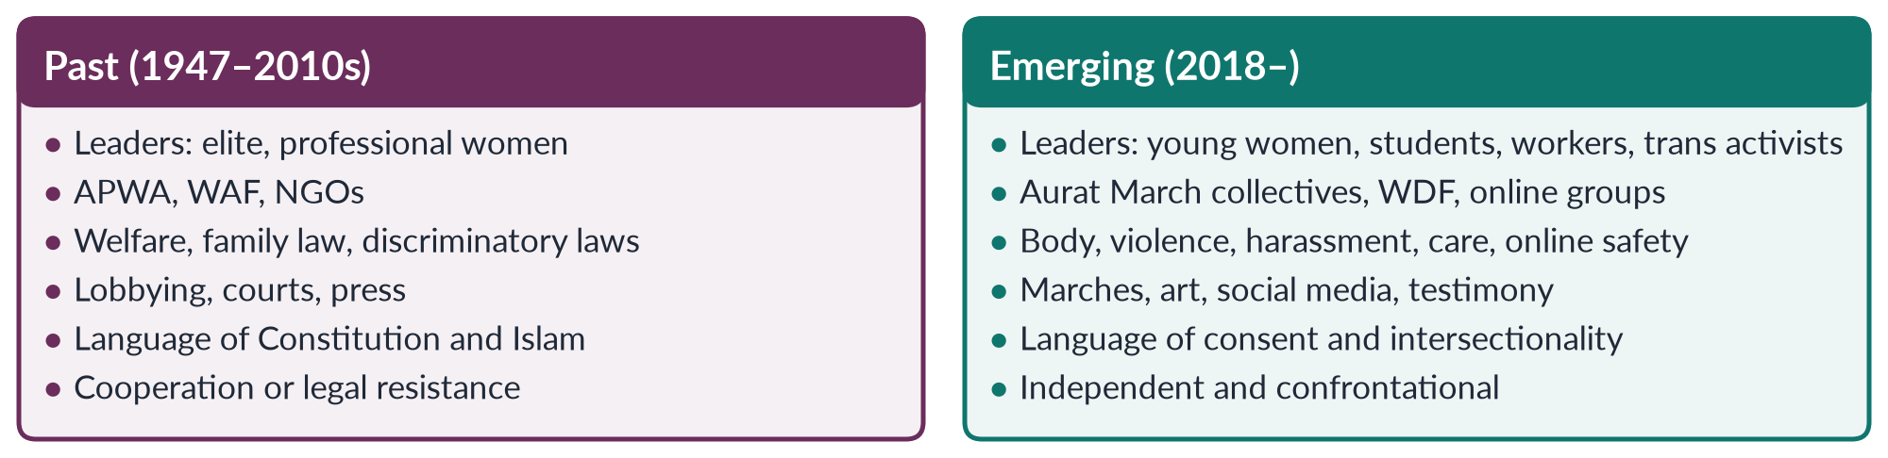
Figure 13 · Past and emerging feminist activism in Pakistan.

10. Effects of the emerging trends

i) Visibility
Women's issues dominate national television every March, and topics once kept private — harassment, marital violence, domestic labour — are now openly debated.

ii) Inclusion
Working-class women, religious minorities, women with disabilities and khawaja siras share the stage. Home-based and domestic workers' demands for wages and labour rights appear alongside demands on violence.

iii) Faster response
Online outrage after the Lahore motorway gang rape (2020) helped produce the Anti-Rape (Investigation and Trial) Act 2021, with special courts and sexual-offences investigation units. Campaigns after the murder of Noor Mukadam (2021) kept pressure on the courts.

iv) Backlash
Court petitions to ban the march, counter-marches and online abuse; slogans such as Mera Jism Meri Marzi were used to discredit the whole movement. Some older activists worry that provocative tactics lose allies the movement needs in Parliament and in families.

v) A digital divide
The mobile-internet gender gap (25% in 2024–25) means rural women remain less represented.

11. Conclusion
Western movements shaped Pakistan's movement deeply but selectively: they supplied tools, platforms and language, which Pakistani women adapted to their own struggles. The emerging trends have made feminism younger, louder and more inclusive, but also more polarising. The past gave the movement laws and legitimacy; the present gives it energy and reach. Pakistan's women need both — the older generation's legal skill and constitutional language, and the younger generation's courage, creativity and inclusiveness.

Why this answer scores
- Impact is shown through channels and wave-by-wave evidence, and its limits are weighed — the answer does not assume simple copying.
- The comparison is point by point, with a compare figure.
- Effects are both positive and negative, with evidence.
- The conclusion joins the two parts: past legitimacy, present energy.

Answer 8 · Principles, Goals and Strategies of the Waves, and Their Effect on Women's Lives (CSS 2025)
AT A GLANCE · CSS 2025 · Q4 · 20 MARKS
Discuss the key principles, goals and strategies of the different waves of feminism. How have these waves affected women's lives?

The answer map
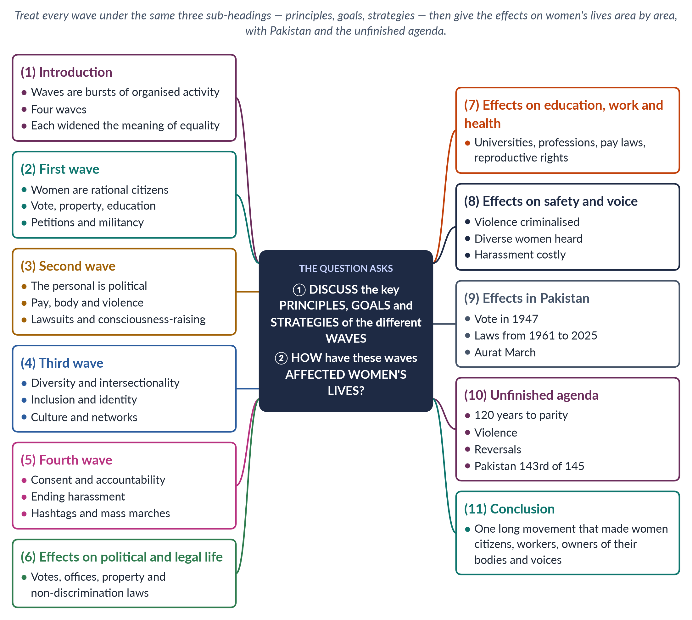
Figure 14 · The answer map: every branch is one numbered heading of the model answer below.

Decoding the question
"Discuss the key principles, goals and strategies" sets three fixed sub-headings for each wave — use them every time, so the examiner can tick them off. "Different waves" allows all four; include the fourth. "How have these waves affected women's lives?" asks for effects, best organised by area of life (politics, law, education, work, health, safety, voice), with evidence, a Pakistan angle and an honest note on what is unfinished.

The model answer

1. Introduction

i) Definition
A wave of feminism is a period of intense, organised activity for women's rights with shared principles, goals and methods. The journalist Martha Weinman Lear made the metaphor popular in 1968.

ii) The four waves
The first (c. 1848–1920), second (1960s–1980s), third (1990s–2000s) and fourth (from about 2012).

iii) The argument
Each wave widened the meaning of equality — from the law, to private life, to differences among women, to everyday safety — and each changed women's lives in lasting ways, though the work is unfinished.

2. The first wave (c. 1848–1920)

i) Principles
Women are rational human beings with the same natural rights as men (Wollstonecraft, 1792; J. S. Mill, 1869). This is liberal feminism: equality before the law.

ii) Goals
The vote; property rights for married women, ending coverture; education and entry to the professions; custody of children and fairer divorce.

iii) Strategies
The Seneca Falls Convention (1848) and its Declaration of Sentiments; petitions and lobbying by suffragists (NUWSS, 1897); militant action by suffragettes (WSPU, 1903) — window-smashing and hunger strikes under the slogan "Deeds, not words". Newspapers, public meetings and huge processions kept the demand in the public eye for seventy years.

3. The second wave (1960s–1980s)

i) Principles
Legal equality is not enough; inequality lives in work, family, sexuality and culture. "The personal is political" (Carol Hanisch, 1970).

ii) Goals
Equal pay and access to jobs; reproductive rights; an end to domestic violence, rape and sexual harassment; shared housework and childcare.

iii) Strategies
Lobbying and lawsuits by the liberal stream (NOW, 1966, Betty Friedan); consciousness-raising groups, marches and protests by the radical stream; building shelters (London, 1971) and rape crisis centres; founding Women's Studies. Paperback books such as The Feminine Mystique (1963) and magazines such as Ms. (1972) carried the ideas to millions of women at home.

4. The third wave (1990s–2000s)

i) Principles
Women are diverse; gender intersects with race, class and sexuality (Crenshaw, 1989); gender is constructed (Butler, 1990); each woman may define feminism for herself.

ii) Goals
Inclusion of women of colour, lesbian and transgender women and women of the global South; sexual freedom and positive self-image; action on harassment and violence; global human rights.

iii) Strategies
Culture — Riot Grrrl music, zines, art and media; voter registration (Rebecca Walker's Third Wave organisation, 1992); transnational networks at Beijing (1995). The early internet and email let activists in different continents share information quickly for the first time.

5. The fourth wave (c. 2012 onward)

i) Principles
Consent, bodily autonomy, accountability of the powerful, and intersectionality as a starting point.

ii) Goals
Ending sexual harassment and violence at work, in public and online; safe spaces; equal pay.

iii) Strategies
Hashtag campaigns (#MeToo, 2017; #NiUnaMenos, 2015), online testimony, viral videos and mass marches organised through social media — such as the Women's March of 21 January 2017. Campaigns now spread across countries within days.
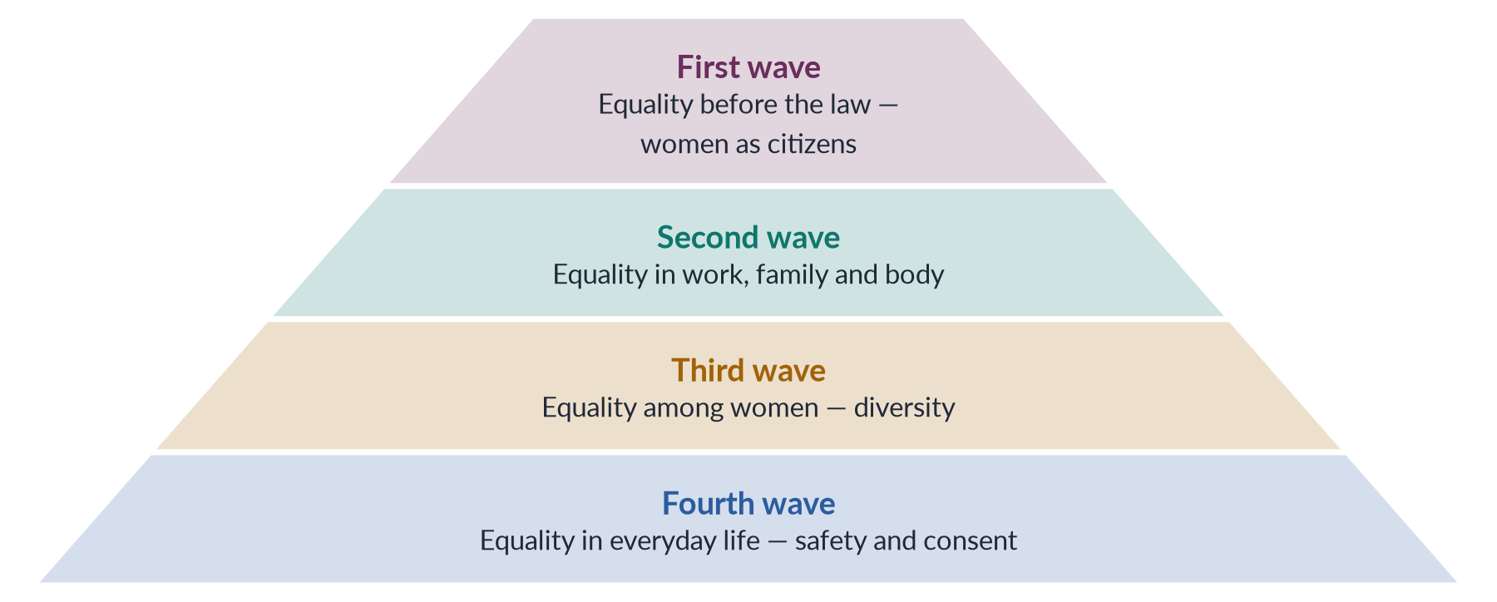
Figure 15 · How each wave deepened the meaning of equality.

6. Effects on political and legal life

i) Votes and office
Women now vote almost everywhere; New Zealand led in 1893. By the mid-2020s about a quarter of the world's parliamentarians were women, and many countries had elected women heads of government.

ii) Legal personhood
The age of coverture is over: married women own property, sign contracts, keep their wages and seek divorce; discrimination on the basis of sex is unlawful in most countries, and CEDAW (1979) sets a global standard.

7. Effects on education, work and health

i) Education and work
Women outnumber men at university in many countries and work in every profession, helped by laws such as the US Equal Pay Act (1963) and Title VII (1964). Pay gaps and "glass ceilings" remain, and women still do most unpaid care work everywhere — the "second shift" after paid work.

ii) Health and the body
The contraceptive pill and legal abortion in many countries (Roe v. Wade, 1973) gave women control over childbearing — though Dobbs (2022) shows such gains can be reversed.

8. Effects on safety and voice

i) Safety
Rape, domestic violence and harassment became crimes; shelters and helplines exist; #MeToo made harassment costly for powerful men. Marital rape, once legal almost everywhere, is now a crime in many countries, and workplaces have complaint procedures.

ii) Voice
Women of colour, lesbian and transgender women and women of the South speak for themselves; ordinary women share experiences with millions online. The idea that women's experience is valid knowledge — a second-wave principle — has become common sense.

9. Effects in Pakistan

i) Law and politics
Pakistani women received the vote in 1947. Family, criminal and political reforms followed: the MFLO (1961), the Protection of Women Act (2006), laws on harassment (2010) and honour killing (2016), 60 reserved seats (2002) and the Islamabad Child Marriage Restraint Act (2025).

ii) Voice
The Aurat March (from 2018) brought fourth-wave activism to Pakistani streets.

iii) Limits
The waves reached Pakistan out of order and together: first-wave goals such as girls' schooling and inheritance are unfinished while fourth-wave campaigns grow online. Pakistan ranked 143rd of 145 in the Global Gender Gap Report 2026, and only 24.4% of women are in the labour force.

10. The unfinished agenda
The world had closed only 69.2% of its gender gap in 2026, with parity 120 years away. About one in three women worldwide has experienced physical or sexual violence (WHO, 2021). Gains can be reversed, as the end of Roe v. Wade and restrictions on women in Afghanistan show. The Beijing+30 review (2025) warned of a growing backlash against women's rights in many countries.

11. Conclusion
The waves differ in principles, goals and strategies, but they form one long movement. The first made women citizens; the second gave them rights at work and over their bodies; the third made feminism plural; the fourth made harassment visible. Women's lives have been transformed — but in countries like Pakistan the transformation is still partial. The next wave's task is to carry these gains to the rural, poor and marginalised women whom earlier waves reached last.

Why this answer scores
- Principles, goals and strategies appear as fixed sub-headings for every wave — exactly what the question asks.
- The fourth wave is included, answering "different waves" in full.
- Effects are organised by area of life, each with evidence, plus Pakistan and the unfinished agenda.
- A pyramid figure summarises how equality deepened.

Answer 9 · From WAF to Digital Activism: Legal Rights to Bodily Autonomy (CSS 2026)
AT A GLANCE · CSS 2026 · Q3 · 20 MARKS
Trace the evolution of the feminist movement in Pakistan, from the activism of the Women's Action Forum (WAF) against the Hudood Ordinances in the 1980s to the digital activism of the 2020s. How has the locus of resistance shifted from 'legal rights' to 'bodily autonomy'?

The answer map
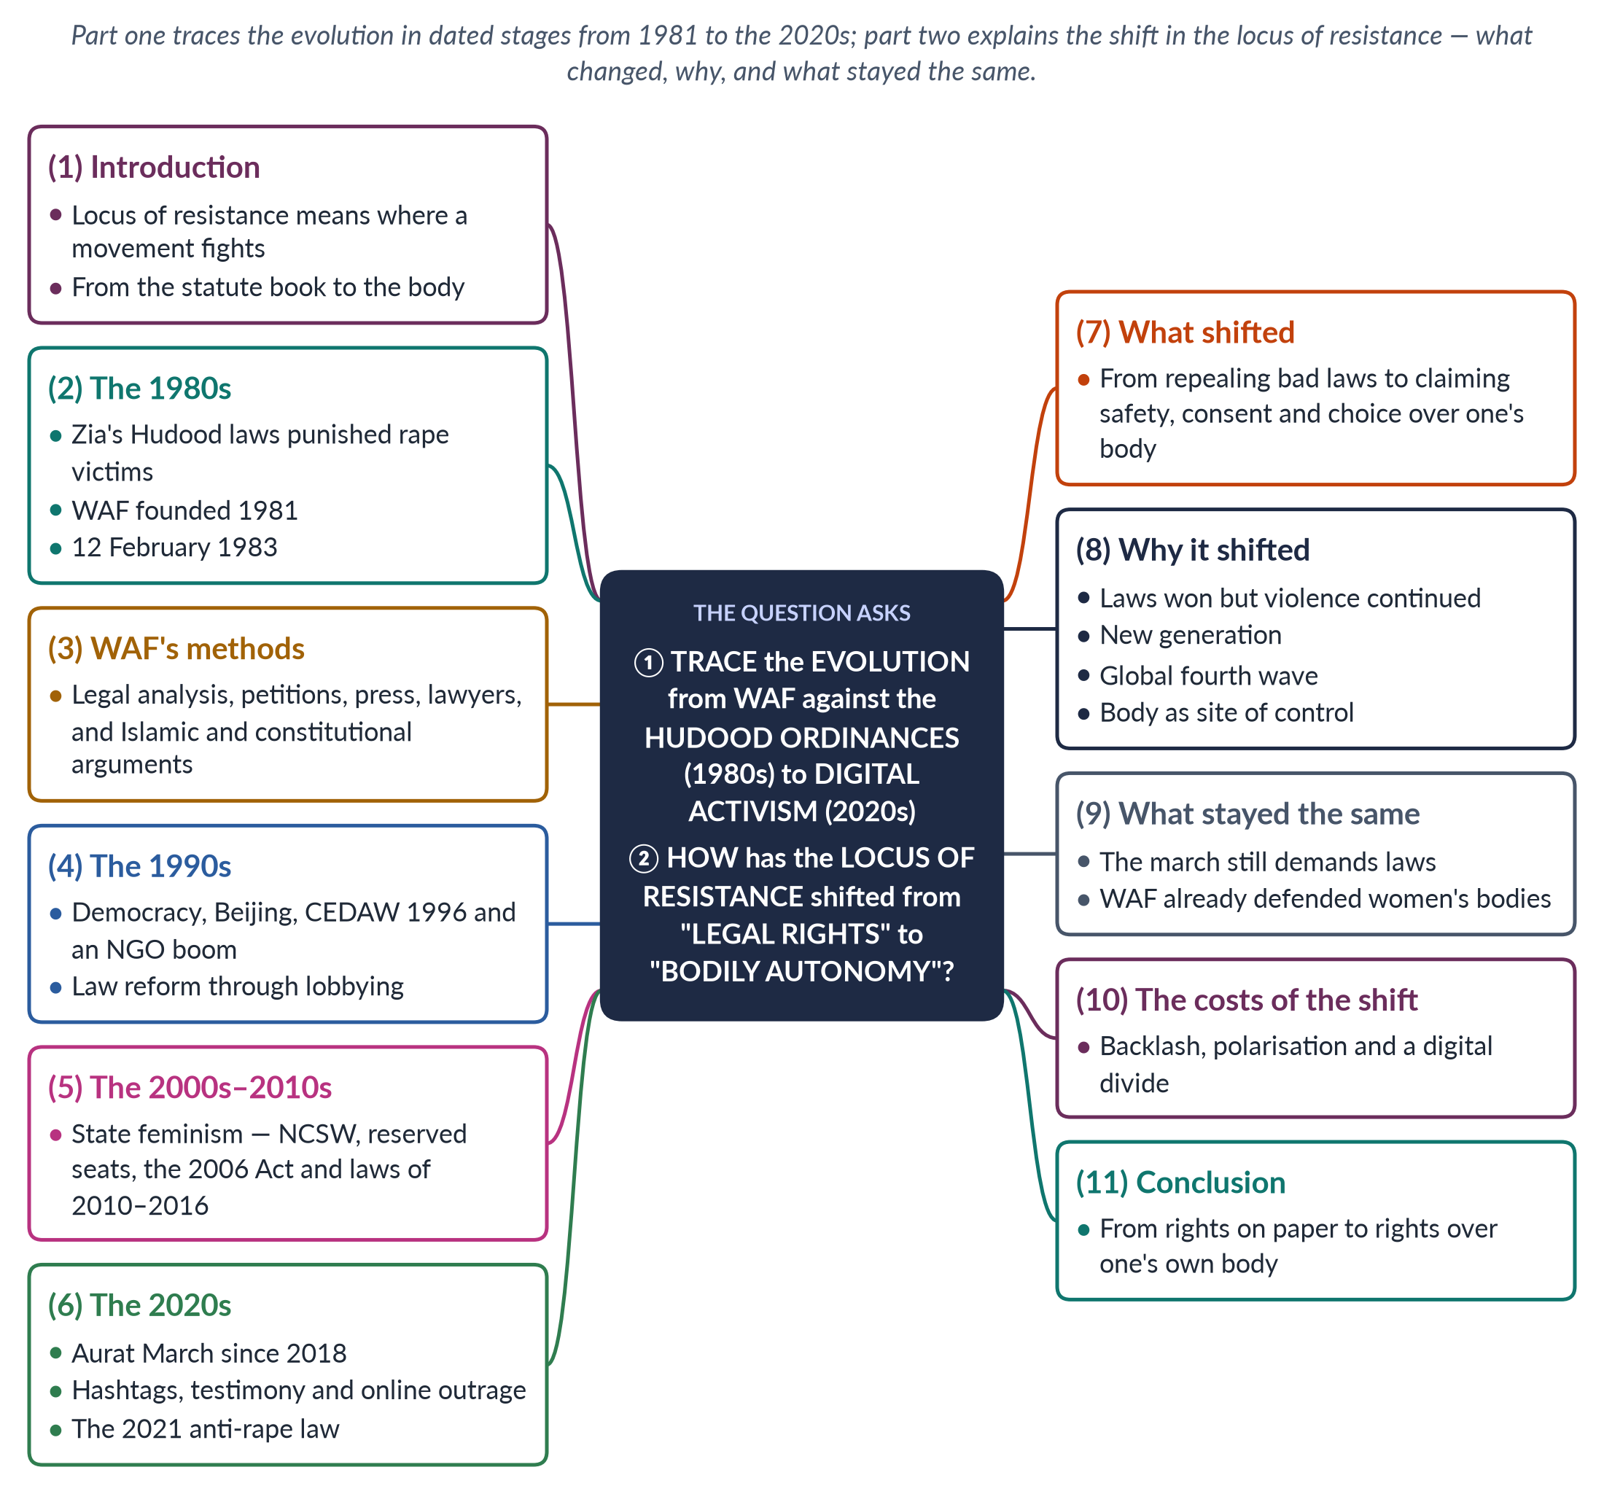
Figure 16 · The answer map: every branch is one numbered heading of the model answer below.

Decoding the question
Two limbs. "Trace the evolution" asks for a chronological account with clear stages from the 1980s to the 2020s — dates, organisations, laws, methods. "How has the locus of resistance shifted" asks you to explain a change: what moved, why it moved, and — for a top answer — whether the shift is as complete as the question suggests. Define "locus of resistance" at the start.

The model answer

1. Introduction

i) Definition
The locus of resistance is the place or focus where a movement concentrates its struggle. For Pakistan's women's movement, the question suggests that this focus moved from the statute book in the 1980s to the female body in the 2020s.

ii) The two poles
Legal rights means equal treatment in law — repealing discriminatory laws and passing protective ones. Bodily autonomy means a woman's right to decide about her own body: freedom from violence, forced marriage and harassment, and choice about marriage and childbearing.

iii) The argument
The shift is real: the movement moved from fighting laws to claiming the body. But the two are linked — laws protect bodies — and the best formula is from rights on paper to rights over one's own body.

2. The 1980s: WAF against the Hudood Ordinances

i) The laws
General Zia-ul-Haq's Hudood Ordinances (1979) included the Zina Ordinance. A woman who reported rape but could not meet its strict standard of proof risked being charged with zina herself. Thousands of women were imprisoned.

ii) The founding of WAF
The Women's Action Forum was founded in Karachi in 1981 after a court sentenced Fehmida and Allah Bux to stoning for marrying against her family's wishes. It was secular, non-party and non-hierarchical, and spread quickly to Lahore, Islamabad and Peshawar.

iii) 12 February 1983
WAF and the Punjab Women Lawyers' Association marched in Lahore against the proposed Law of Evidence, which would count two women's testimony as one man's in some cases. Police baton-charged them. The day is now National Women's Day.

3. WAF's methods

i) Law as the battlefield
WAF produced legal analysis of the ordinances, documented cases such as Safia Bibi (1983) — a visually impaired rape victim convicted of zina — and supported women lawyers such as Asma Jahangir and Hina Jilani in court.

ii) The language of rights
It argued through the Constitution (Articles 25 and 34) and through alternative interpretations of Islam, inviting scholars to debate. Its target was the state and its laws. Because military rule banned political parties, WAF's statements and marches were among the few public challenges to the regime.

4. The 1990s: democracy, the UN and NGOs

i) Openings
Benazir Bhutto (1988) created women's police stations and the Lady Health Worker Programme, though the Hudood laws were not repealed. Pakistan joined Beijing (1995) and acceded to CEDAW (1996).

ii) NGOs
A boom of NGOs researched violence and lobbied for reform; the focus was still law and policy. The killing of Samia Sarwar (1999) put honour killing on the national agenda.

5. The 2000s–2010s: state feminism

i) Institutions
The NCSW (2000), 60 reserved National Assembly seats (2002) and the Women's Parliamentary Caucus (2008) brought women's demands inside the state.

ii) Legal victories
The Protection of Women Act 2006 moved rape from the Zina Ordinance into the Penal Code — the central demand of WAF's campaign. Laws on harassment (2010), acid attacks (2011) and honour killing (2016) followed. The legal struggle was largely won on paper.

6. The 2020s: digital activism and the Aurat March

i) The Aurat March
Since 8 March 2018, young women have marched in Karachi, Lahore, Islamabad and other cities. Their placards speak of harassment, marital violence, domestic labour, forced marriage and Mera Jism Meri Marzi ("My body, my choice").

ii) Digital tools
Hashtags, personal testimony and viral videos spread campaigns; #MeToo reached Pakistan in 2018. Online outrage after the murder of Qandeel Baloch (2016), the Lahore motorway gang rape (2020) and the killing of Noor Mukadam (2021) pushed the state to act, including through the Anti-Rape (Investigation and Trial) Act 2021.
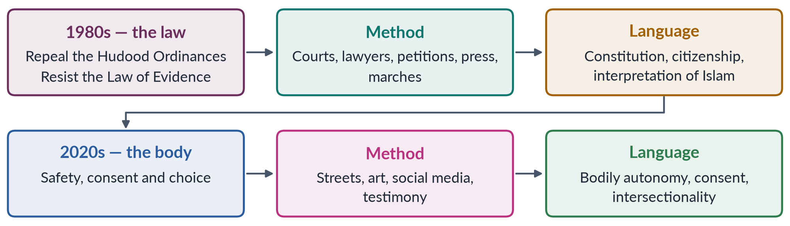
Figure 17 · The shift in the locus of resistance.

7. What shifted

i) The target
From the state and its laws to society, the family and everyday life — the home, the street, the workplace and the screen.

ii) The issues
From discriminatory statutes to violence, harassment, forced marriage, marital rape and control over mobility and dress.

iii) The language
From equal citizenship and Islamic interpretation to consent and bodily autonomy.

8. Why it shifted

i) Laws won, violence continued
The biggest legal battles had been won by 2016, yet honour killings, rape and harassment continued. Activists concluded that the problem lay less in the statute book than in social control of women's bodies.

ii) A new generation
Young, urban women raised on the internet framed problems through personal experience. Many had grown up with the legal gains of the 2000s and took them for granted; their question was why daily life still felt unsafe.

iii) The global fourth wave
#MeToo (2017) and consent campaigns worldwide supplied language and tools.

iv) The body as the site of control
Honour, forced marriage and harassment all rest on the idea that a woman's body belongs to her family's izzat (honour). Claiming the body strikes at the root.

9. What stayed the same

i) The march still demands laws
The Aurat March calls for laws on domestic violence and child marriage and for enforcement of harassment law; the Islamabad Child Marriage Restraint Act 2025 answered such demands.

ii) WAF already defended bodies
WAF's campaign was itself about women's bodies — against flogging, stoning and the treatment of rape victims.

10. The costs of the shift
The new language provoked backlash: petitions to ban the march, counter-marches and online abuse. Critics heard "bodily autonomy" as sexual permissiveness, and older allies worried about losing support in Parliament and among religious scholars who had backed earlier laws. The digital divide — a 25% mobile-internet gender gap — means rural women are less represented.

11. Conclusion
From WAF's legal battles of the 1980s to the digital activism of the 2020s, Pakistan's movement has moved its locus of resistance from repealing bad laws to claiming women's bodies from violence and control. The shift reflects success as much as frustration: laws were won, but lives did not change enough. The two struggles are best seen as one — rights on paper made real as rights over one's own body.

Why this answer scores
- The evolution is traced in dated stages, not summarised.
- "Locus of resistance" is defined, and the shift is explained by what, why and what stayed the same.
- A flow figure shows the two poles at a glance.
- The answer tests the question's claim, showing continuity as well as change — examiners reward this.

Answer 10 · The NGO-isation of the Women's Movement in Pakistan (CSS 2026)
AT A GLANCE · CSS 2026 · Q6 · 20 MARKS
Critically examine the 'NGO-ization' of the women's movement in Pakistan. Has the donor-driven agenda of gender mainstreaming depoliticized the feminist struggle, converting it into a technocratic 'project' rather than a social revolution? Use the WAD (Women and Development) critique in your answer.

The answer map
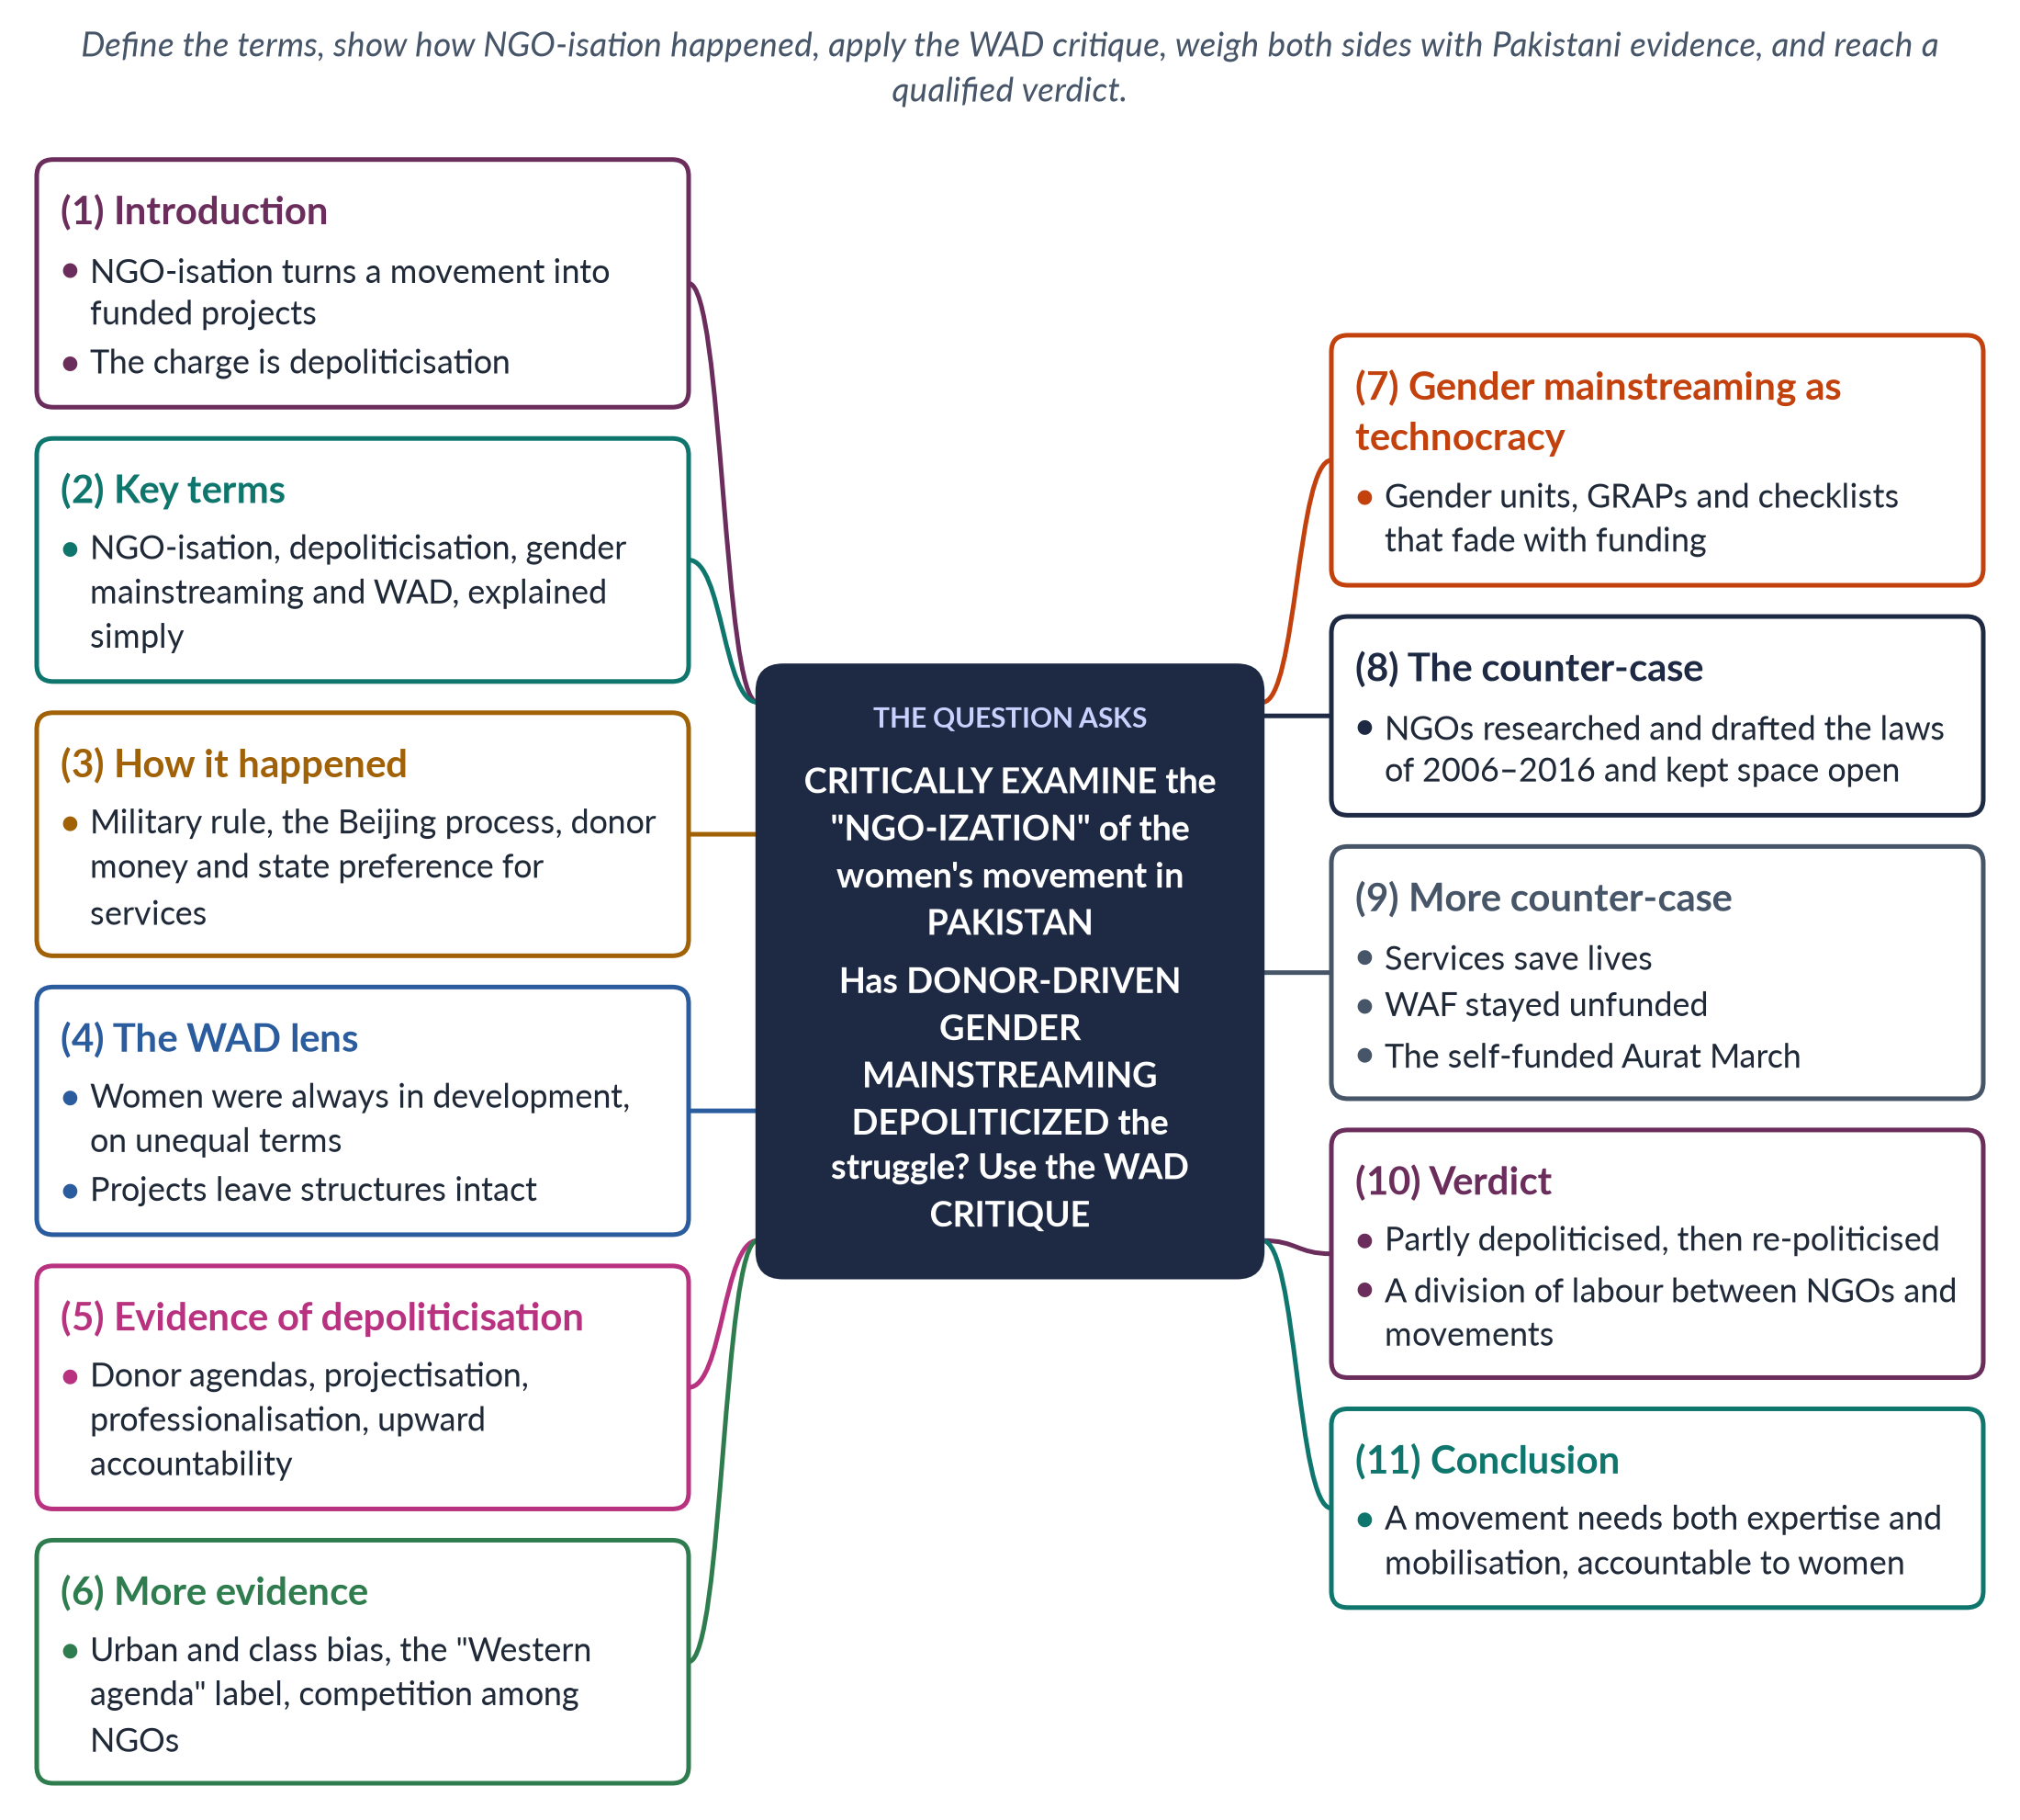
Figure 18 · The answer map: every branch is one numbered heading of the model answer below.

Decoding the question
"Critically examine" asks for both sides and a reasoned verdict, not agreement with the question's claim. Explain each loaded term — NGO-ization, donor-driven, gender mainstreaming, depoliticized, technocratic project, social revolution — and use the WAD (Women and Development) critique explicitly, as instructed. Pakistani evidence must support every point.

The model answer

1. Introduction

i) Definition
NGO-isation is the process by which a social movement's energy moves into professional, formally registered, donor-funded non-governmental organisations. Activists become paid staff, campaigns become projects, and accountability runs upwards to donors rather than outwards to members.

ii) Scholars
The idea was developed by Sonia Alvarez (on Latin America, 1999) and Islah Jad (on the Arab world, 2004).

iii) The argument
NGO-isation partly depoliticised Pakistan's women's movement, as the WAD critique predicts. But NGOs also produced laws, data and services, and the movement has re-politicised itself. The verdict is mixed.

2. The key terms

i) Depoliticisation
Turning a struggle about power — who owns, who rules, who decides — into a technical problem managed by experts. The question contrasts a "technocratic project" with a "social revolution".

ii) Gender mainstreaming
Endorsed at Beijing (1995): assessing every policy for its effects on women and men, instead of confining women to separate projects.

iii) WAD — Women and Development
A late-1970s critique, drawing on Marxist and dependency theory, of WID (Women in Development). WID said women were left out of development and should be integrated. WAD replied that women were always part of development — but on unequal, exploitative terms set by class and global capitalism.

3. How NGO-isation happened in Pakistan

i) Early organisations
Shirkat Gah (1975) began as a research and legal-rights collective. WAF (1981) was a voluntary platform that deliberately refused funding.

ii) The drivers
Military rule closed political space in the 1980s, so activists turned to organisations. After Beijing (1995) and CEDAW (1996), donors funded "gender and development" projects; hundreds of NGOs formed. NGOs offered jobs and some protection, and governments welcomed their service delivery.

iii) Growth and regulation
The 2000s brought donor-funded programmes on women's political participation and violence. From 2015, tighter state regulation of foreign-funded NGOs reduced this flow.

4. The WAD lens applied

i) Integration into an unequal system
Many projects offered women micro-credit, handicraft training or income generation. From the WAD standpoint, these integrate women into the existing economy without changing land ownership, feudal power, wage exploitation or unpaid care.

ii) An example
A home-based embroiderer trained by a project still sells to a middleman at piece rates and still does all the housework. Her income may rise slightly; her position does not change. WAD would ask instead who owns the land she works, who sets the piece rate, and who does the unpaid care that fills her day — questions that three-year projects rarely touch. This is the "project rather than revolution" the question describes.
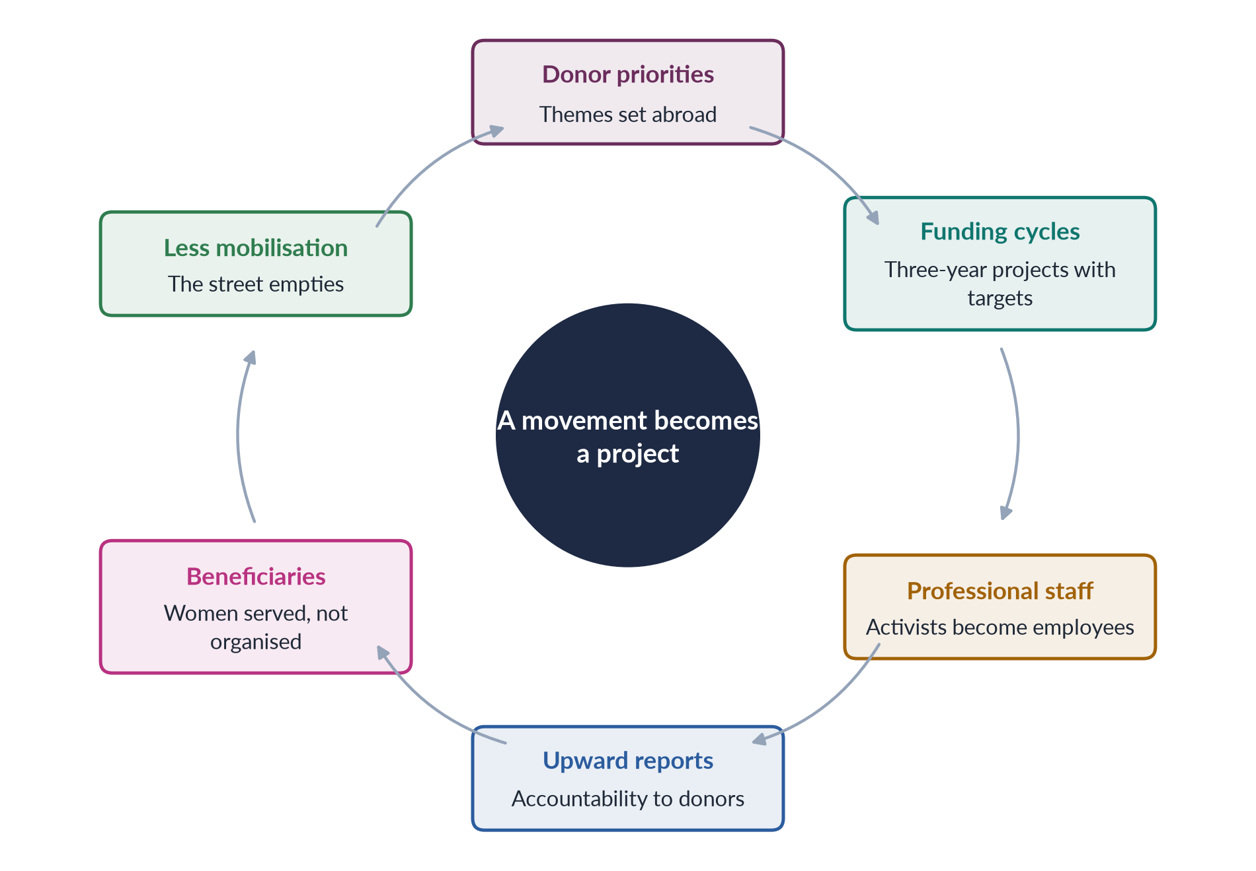
Figure 19 · How a movement becomes a project, as the critics describe it.

5. Evidence of depoliticisation (1)

i) Donor-driven agendas
Priorities followed donor fashions — micro-credit, then governance, then violence — rather than the demands of women themselves, and changed whenever a funding cycle ended.

ii) Projectisation
Three-year projects with log-frames and "deliverables" cannot sustain long struggles against feudal or patriarchal power.

iii) Professionalisation
Paid experts and gender consultants replaced volunteers; English-language reports replaced mass mobilisation.

iv) Upward accountability
NGOs answered to donors and their evaluations, not to the women they served.

6. Evidence of depoliticisation (2)

i) Urban and class bias
Offices clustered in Islamabad, Lahore and Karachi; rural women became "beneficiaries" rather than leaders.

ii) The legitimacy cost
Foreign funding let opponents dismiss feminism as a "Western agenda".

iii) Competition
NGOs competed for grants instead of building one movement, and some rural women came to see NGOs as employers or service providers rather than allies in a shared struggle.

7. Gender mainstreaming as technocracy
After Beijing, Pakistan adopted a National Plan of Action (1998), the National Policy for Development and Empowerment of Women (2002) and donor-supported Gender Reform Action Plans. They created gender units and gender-budgeting pilots — but critics describe many of these as checklist exercises run by consultants, understaffed and fading when funding ended. "Gender" often meant a training workshop rather than a shift of power.

8. The counter-case (1): what NGOs achieved

i) Laws
NGOs such as Shirkat Gah and the Aurat Foundation, working with women legislators, researched, drafted and lobbied for the Protection of Women Act 2006 and the laws on harassment (2010), acid attacks (2011) and honour killing (2016). Lawmaking is deeply political.

ii) Space under repression
When parties were banned or weak, NGOs kept women's issues alive and trained women councillors after the 2001 local-government reforms. They also built the data on violence and women's work — from newspaper monitoring to legal case records — without which Parliament could not have acted.

9. The counter-case (2): services and revival

i) Services save lives
Shelters, legal aid and helplines are not "depoliticised" to a woman escaping violence. Helping one woman leave an abusive home, or win her inheritance in court, changes power relations in that family — the personal is political.

ii) Not all NGOs are alike
WAF stayed unfunded and independent; many NGOs combine services with advocacy.

iii) The movement revived
The self-funded, volunteer-run Aurat March (from 2018) shows that grassroots feminism survived NGO-isation — and rural movements such as the Sindhiani Tehreek never depended on donors.
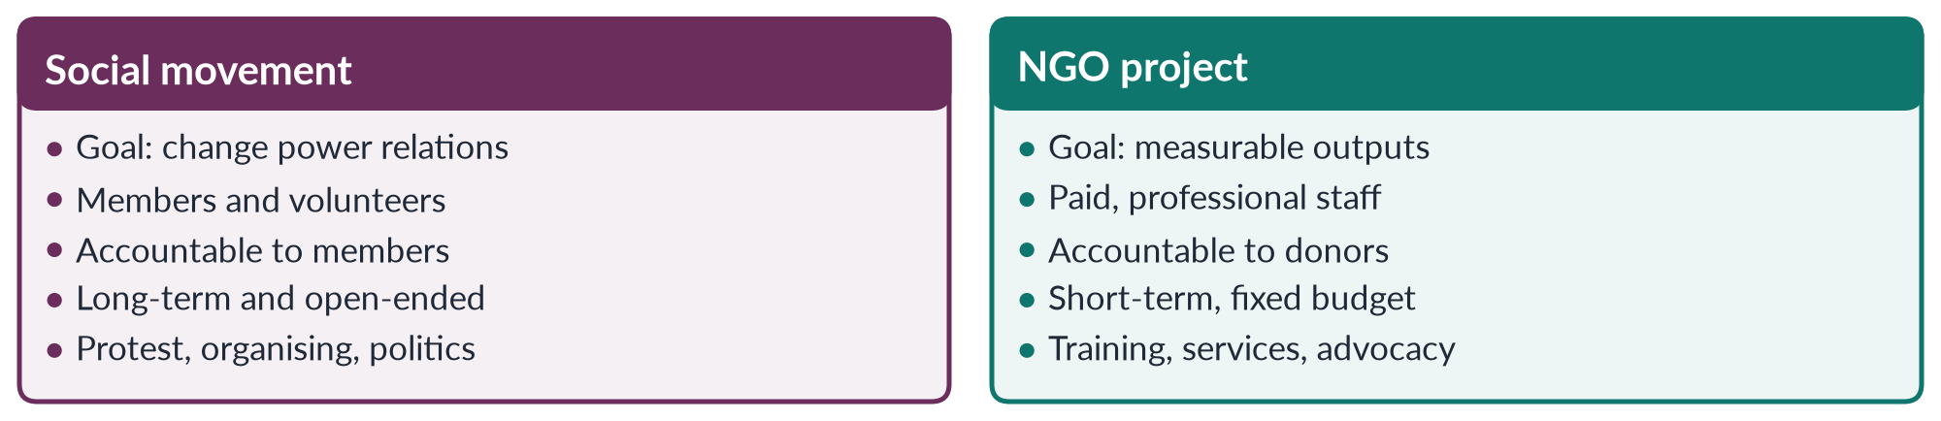
Figure 20 · A social movement and an NGO project.

10. The verdict

i) Partly true
The question's claim is partly true. Donor agendas, projectisation and professionalisation weakened mass mobilisation and made much gender work technocratic — as the WAD critique predicts.

ii) But incomplete
NGOs also produced laws, data and services, and the movement has re-politicised itself through WAF's legacy, rural struggles and the Aurat March.

iii) The way forward
A division of labour: NGOs for expertise, research and services; independent movements for mobilisation and politics. Both need local funding and accountability to women themselves.

11. Conclusion
NGO-isation turned parts of Pakistan's women's movement into a technocratic "project", as its critics and the WAD lens suggest. Yet it also helped win the laws of 2006–2016 and never fully replaced grassroots activism. The movement's challenge is not to choose between NGOs and revolution, but to make expertise serve mobilisation — so that gender work once again changes power, not only programmes.

Why this answer scores
- Every loaded term is defined, and the WAD critique is applied explicitly with an example.
- Both sides are argued with Pakistani evidence, as "critically examine" requires.
- A cycle figure and a compare figure make the argument visible.
- The verdict is qualified and reasoned, with a practical way forward.

